Date: 8/1/2013

Entry: Approach Retraction Theory

Today, I learned about the crux of the project which is the Shear Force Acoustic Near-Field Microscopy or SANM. I then learned about the different types of scanning probe microscopy such as Scanning Tunneling Microscopy, Near-Field Scanning Optical Microscopy, and Atomic Force Microscopy. SANM most closely resembles that of a STM and an AFM. SANM uses a probe to detect changes in the resonant frequency just like the AFM but uses a vertical approach that is similar to that in the STM. SANM essentially consists of a probe that is driven by an electrical signal at a single excitation frequency. The single excitation frequency is the resonance frequency of the tuning fork and approximately lies in the 31 to 32 kHz range. I am pretty amazed at the technique used by SANM because of the creative method of analyzing the mesoscopic fluid sandwiched between two solid objects. The probes I have been fabricating is one solid boundary and the substrate is the other solid boundary. But what really caught me is that the machine is able to get high resolution due to the fact that the fabricated tip has a small boundary on the scale of microns.

Mesoscopic Fluid

Sample

Probe

Date: 8/2/2013

Entry: Approach Retraction Theory Pt. 2

Referring to the previous day, the amplitude of the tuning fork actually decreases as the mesoscopic layer. The mesoscopic layer is very viscous so it reduces the amplitude of the tuning fork and the damping amplitude can be attributed to the mesoscopic fluid. I am even more amazed at this technique than I was the day before. I even more surprised by the acoustic sensor lying underneath the sample. The acoustic sensor simply hears the disturbances in the mesoscopic fluid. That sensor has to be really sensitive in order to sense those signals. That is really unique because it lets me "listen" on the signal produced by the probe.

The other unique aspect I found was the whole implementation of this thing is done through LabVIEW. The LabVIEW program controls the approach and retraction of the probe into the surface of the tip. I will learn the FPGA, LabVIEW program, and machinery after my trip to Peru.

Date: 8/19/2013

Entry: The Lock-In Amplifier in the SANM setting

The first piece of instrumentation in SANM is the Lock-In Amplifier. I learnt the basics of the LIA and that is to read certain components of an electronic signal. Below, I create a simple representation of a LIA.

Filter

Multiplier

Reference

Signal

Phase Locked Loop

A Lock-In has a reference and a signal as two inputs. The reference matches the frequency of the signal and helps the Lock-In figure out the data. The reference is sent through a PLL so that the Lock-In can create its own replication of the signal and this way it knows the information of the signal it created. It then multiplies the signal and the multiplication of the signal reveals important components of the signal. The multiplication of two trig signals actually creates two wave functions so that is why the filter is used to eliminate the unneeded component.

Date: 8/20/2013

Entry: FPGA  
 The FPGA is a data acquisition method that is an integral part in SANM. The FPGA is the key component that receives the data from the quartz tuning fork, Lock-In, and MCL. The MCL is a piezoelectric that when a voltage is given, the piezoelectric will expand or contract depending on the sign and magnitude of the voltage. The MCL is the component that controls the approach or retraction of the probe towards the substrate. I realized that the FPGA is used because it is just faster at grabbing data than the computer. The FPGA is a modifiable piece of hardware and software that can be customized to the needs of the user. In my case, the FPGA is modified as a data acquisition device. The FPGA is a piece of hardware that is inserted into one of the PCI slots into the computer. The FPGA can be interfaced with LabVIEW and I noticed that the LabVIEW not only monitors the tuning fork but also controls the FPGA. The programming of the FPGA is a little different than programming in LabVIEW. In order to communicate with the FPGA, I needed to open a communication line with the FPGA to obtain the data. Then, once the reference is complete, I needed to abort or terminate the reference to maintain the correct type of code.

Date: 8/21/2013

Entry: FPGA Pt. 2

To program the FPGA in a broad view, I learnt that there are two types of programs. The first program is the host and the other is the target. The host program is the program that interfaces the connection between the computer (host) and the FPGA. In the host program, all the data from the FPGA is displayed and manipulated to represent the functions. The other type of

program is the target program. The target program is the program that is programmed on the FPGA itself and it contains the code that will be generated on the FPGA. This is where I tell what exactly the job of the FPGA is. Once the target program is finished, I realized that every time I make a change or make a target program, I need to compile to fit the format of the FPGA. Below is the communication between the computer and FPGA.

FPGA

Target Program

Host (Computer) Program

Date: 8/23/2013

Entry: LabVIEW Program of the Approach/Retraction

The program of the Approach/Retraction contains several components: FPGA control, MCL control, tuning fork monitoring, acoustic sensor monitoring, and data acquisition control. The FPGA control is controlled through referencing the target program on the FPGA and communicating with the FPGA program to be able to extract the data and to properly interpret the data. The LabVIEW program has several graphs that depict the data components of the tuning fork amplitude and the signals of the acoustic sensor. The MCL control is utilized to manually or automatically control the movement of the piezoelectric. The range of the MCL is 0-60 micron range and the driving voltage ranges from -10 to 10 volts. By keeping the voltage constant at a specified rate, the LabVIEW program constantly monitors the expansion of the MCL and manipulates the driving voltage based on the tuning fork signal. If the signal is getting low below a certain percentage of the signal, I realized that the MCL controlled by the LabVIEW program will switch its driving voltage to respond to that circumstance. If the tuning fork signal suddenly drops 50%, the MCL will completely reverse gears and immediately start a retraction of the probe. I call these fast controls because the fast acquisition of the FPGA combined with the automatic approach of the LabVIEW require the user, me, to do nothing but watch and monitor. Here is a picture of the front panel of the SANM program.

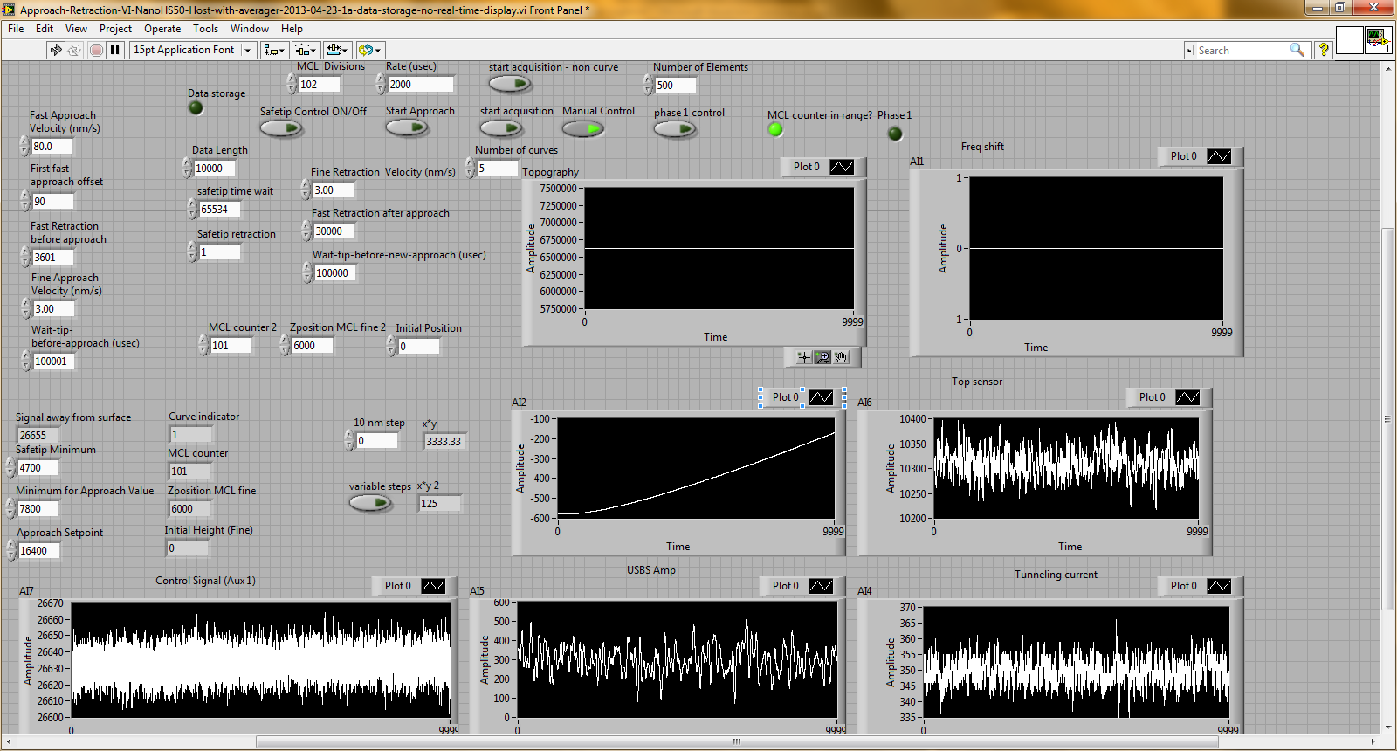

The boolean controls on the top of the program control the entire functionality of the program. The controls on top control which modes such as automatic or manual approach/retraction are on and which data is being analyzed. The graphs in the program display all the inputs and outputs that are connected to the FPGA and the computer. The main interest is the left bottom graph which represents the tuning fork signal. The approach/retraction automatic completely relies on the ultrasensitive signals detected by the tuning fork. The 4 controls on the bottom left all initialize the settings where should the approach stop, when should the stage retract, what is the emergency setting, and what is the required signal to initialize the next steps. The controls on the top left and in the top middle control the approach/retraction of the MCL stage. Here, the velocities of the approach or retraction can be controlled. The AI2 graph displays the MCL driving voltage output and the Topography graph represents the signal LabVIEW is outputting to move the MCL.

Date: 8/27/2013

Entry: Learning the Lock-In Amplifier

The Lock-In Amplifier that is used to power the SANM approach retraction is the SR-850. In order to properly use the instrumentation, I needed to properly learn how to operate the machine and control the resonance frequency of the tuning fork. I learnt many components that control the Lock-In: frequency, phase shift, signal generator mode, voltage, sensitivity, reserve, time constant, sample rate, and scan length. The SR-850 is a very unique Lock-In Amplifier because it both contains a PLL and a signal generator. The frequency is the part of the signal generator where I can control the output of the generator. The phase shift is similar to the frequency. I can apply a phase shift up to 360 degrees and modify the signal I wanted to create. The signal generator mode tells the Lock-In what type of signal is going to be outputted and there are three modes: internal, internal sweep, and external. The internal is essentially the Lock-In's signal generator and it uses that. The internal sweep uses the internal signal generator but it does a sweep which means that it outputs a voltage that at each progressive moment, the frequency is increased within the interval. I did a frequency sweep of a quartz tuning fork from 31.5 kHz to 33.0 kHz. Depending on the scan length, the period in which the Lock-In obtains data, the frequency will "sweep" or move from 31.6 kHz to 31.7 kHz ten seconds later. The voltage merely manipulates the output voltage of the signal generator. I learned that half of the controls in the SR-850 control the signal generator and the other half actually controls the Lock-In. The sensitivity, reserve, time constant, sample rate, and scan length are all options of the Lock-In. The scan length is simply the amount of time dedicated to obtain data about a certain signal. The reserve controls the amount of noise coming in from the signal. By optimizing reserve signals, I realized that I could obtain a small amount of noise and high resolution. The time constant is the time needed for the filter inside the Lock-In Amplifier to recharge. If you put the value smaller than the optimal limit, you force the Lock-In to get a data rate that exceeds the discharging of the capacitor in the filter. The larger time constant the better. The sample rate is also very similar to that of the time constant. The sample rate is essentially the number of times the Lock-In will sample the electric signal and obtain data points. A 32 Hz sample rate essentially means 32 points in a second. The sensitivity essentially controls the range of the measure voltage.

Date: 8/30/2013

Entry: Learning the MCL

The MCL is essentially piezoelectric that contains no hysteresis due to the capabilities provided by the MCL. A piezoelectric is a ceramic that expands or contracts on the scale of microns. The MCL is very similar and is a metal that expands or contracts when a voltage between -10 to 10 volts is applied. The range of the MCL is 60 microns one way or the other. Most piezoelectric when a voltage is applied will expand but when the same voltage with an opposing sign is applied to retract the expansion does not necessarily contract completely. This is called hysteresis. My main question was how exactly do we get rid of this problem? The MCL contains electronic circuits such as a string gage which essentially tracks the movement of the piezoelectric and will tell a machine to keep on supplying voltage until the piezoelectric is back to its original state.

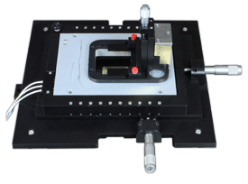

This is a sample picture of the MCL. I have an MCL that can expand or contract the piezoelectric in only one dimension. That is why it is called a z-position MCL. The MCL is completely controlled by LabVIEW with the program telling how much voltage the MCL should supply its piezoelectric.

Date: 9/12/2013

Entry: Experimenting with the Approach Retraction Program

Essentially today I wanted to investigate how the whole program works. I wanted to start first with host program and the slowly work my way through all the while loops. Once I have finished the host, I will analyze what the host is calling form the FPGA. By understanding the relationship, I relate the connection between the target program and the host program and learn how the whole program functions. The first section I analyzed was the data storage implementations in the program. I see that the curve indicator tells how many curves I want to run for data. The name file and extension create an excel to store the data. The several local variables I had learnt was an important function. I just saw that a local variable calls another variable and instead of implementing the same function, it is more practical to use the local variable. I know I will be using the local variable a lot.

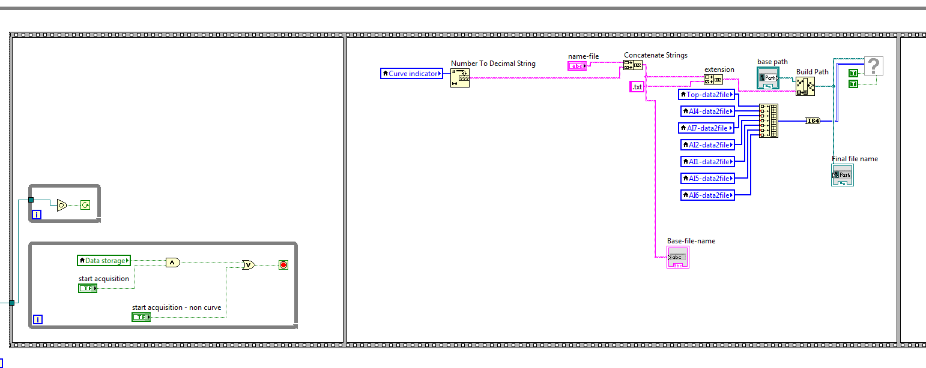

Then the information goes to a build path. The build path is essentially a function where LabVIEW creates a file on the desktop. All of this is then condensed into the write to spreadsheet.vi. The write to spreadsheet.vi essentially gathers all the data and location of the file and places the data in that location. As the program is running and data acquisition is on, I saw that the data is being automatically place as it is being recorded.

Date: 9/19/2013

Entry: Experimenting with the Approach Retraction Program Pt. 2

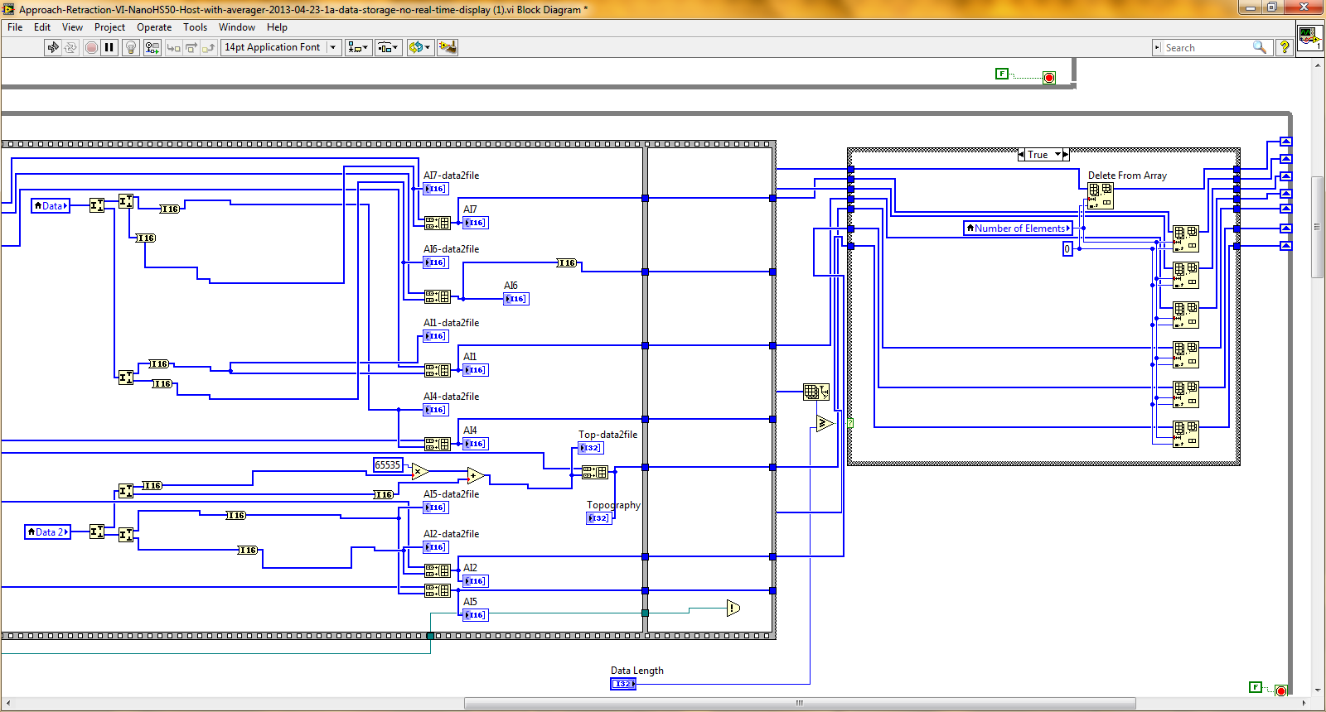

The picture above represents the second while loop. In this while loop, all the program is doing is taking the data and converting it into an I16 integer or an I64 integer. The I16 integer ranges from -32727 to 32727 and the I64 integer ranges from huge numbers to huge numbers. I mainly realized that depending on the data input, an I16 or I64 is being used. The AI# blue indicators are all graphs on the front panel of the program. Basically, all the data is being converted, transferred into an array, and then displayed on the graph. I personally like to see graphs because getting real time continuous data helps me visualize and think faster.

Date: 9/20/2013

Entry: Experimenting with the Approach Retraction Program Pt.3

The rest of the approach/retraction host program is displayed below.

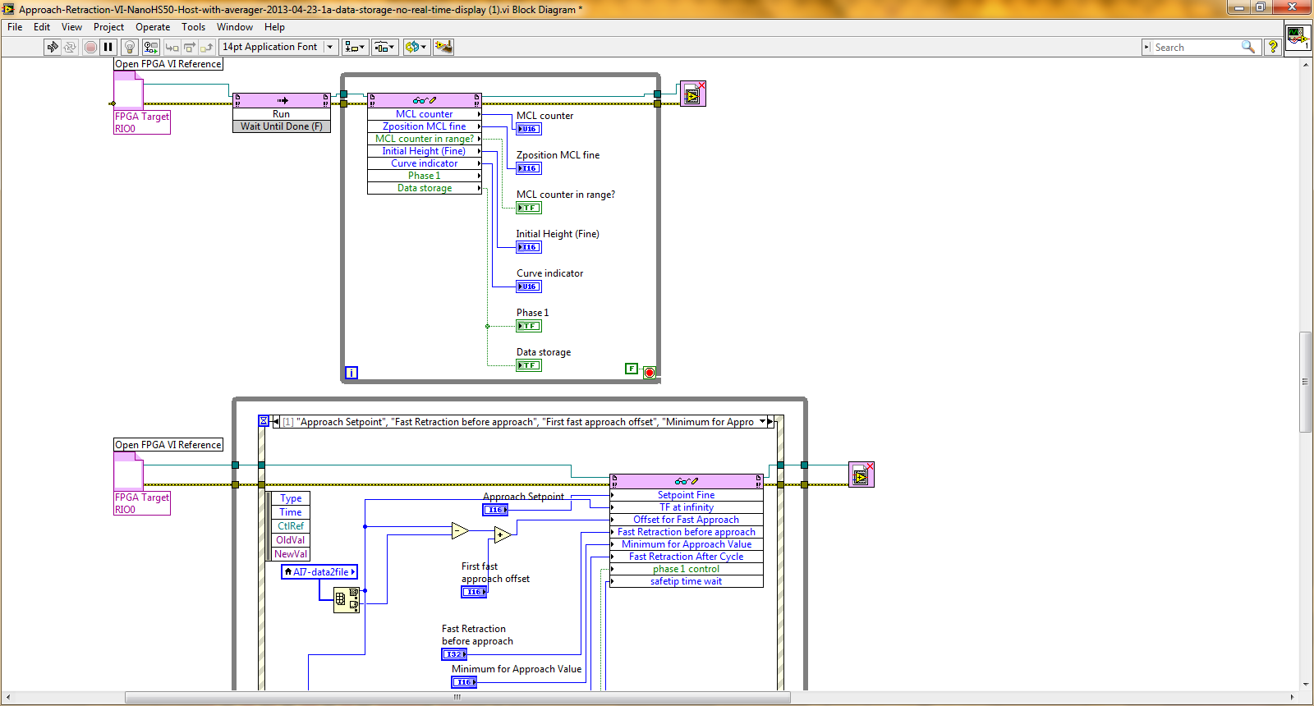

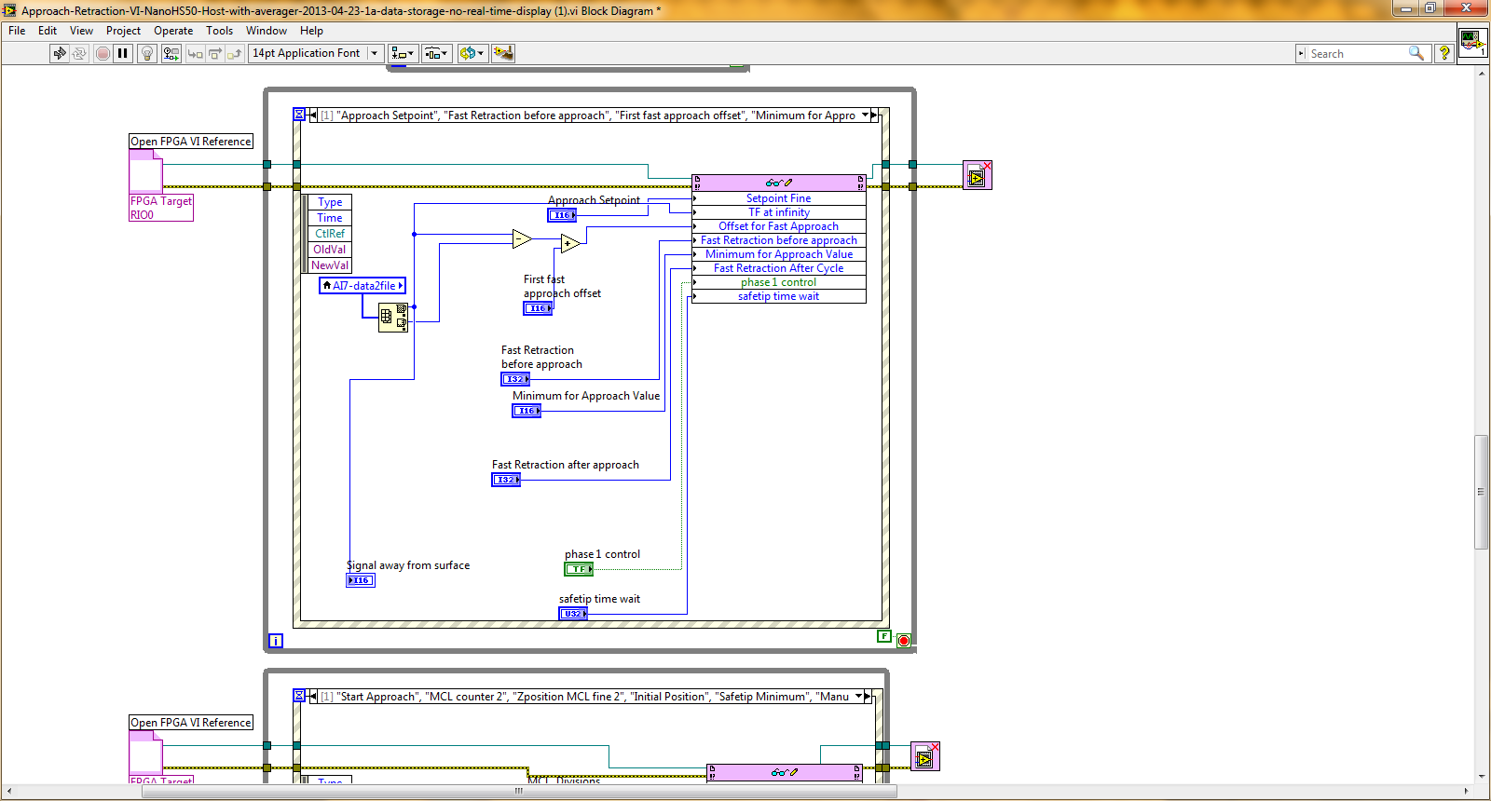

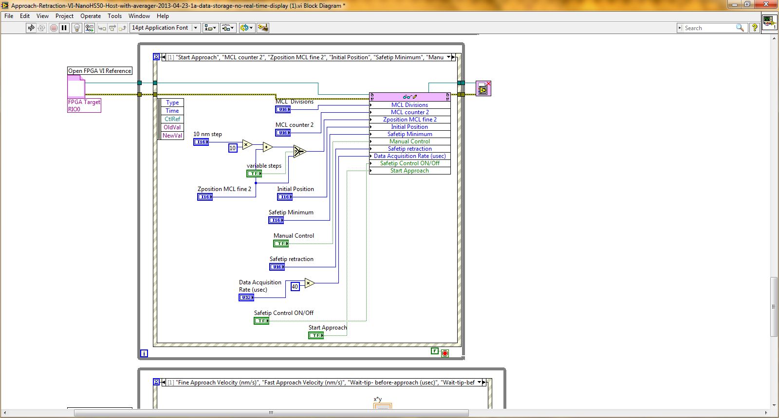

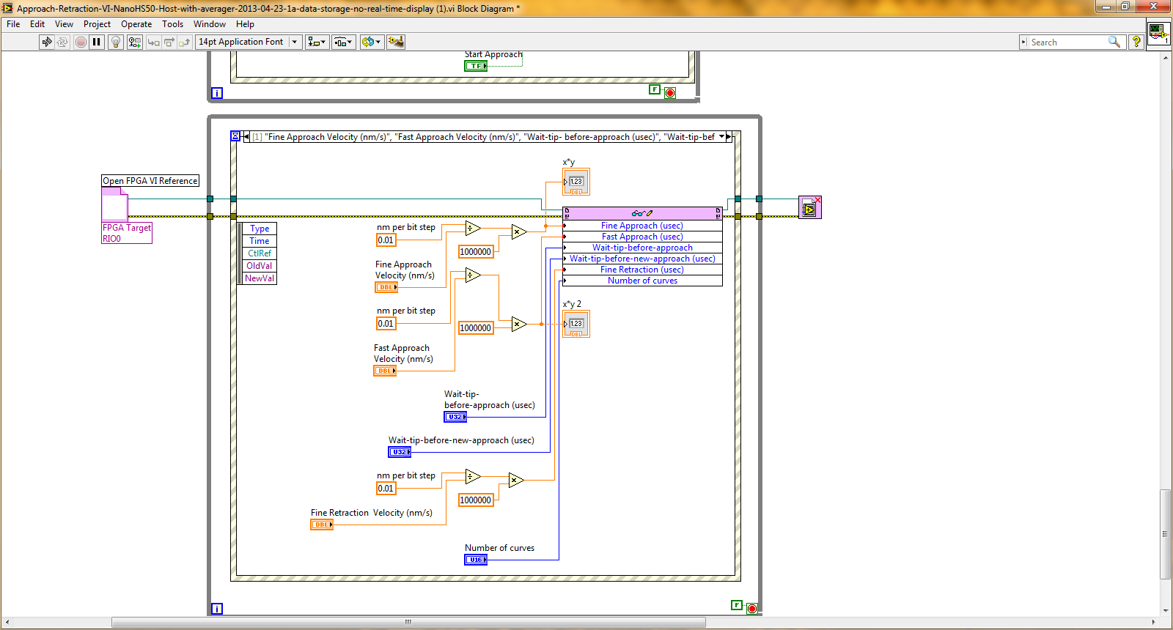

In all of these while loops inside the approach/retraction program, they all contain an Open FPGA VI Reference and then at the end of the while loop there is a close FPGA VI Reference. The Open FPGA VI Reference communicates with the FPGA to understand and get the data and functions of the target program. The read and write file that has glasses in the program block is where the entry and exit of data happens to and from the target program. If the wires are hooked up into the read and write file, the data is actually writing to the FPGA target program. If the wires are coming out of the read and write file and flowing into indicators then it means that is reading data from the FPGA and streaming them out. The while loop essentially runs forever until a boolean control turns false and the while loop will stop. In the while loops, a secondary loop is also included. The second loop is the case structure. The case structure essentially executes the program if a certain condition is met or it is programmed to alternate between two situations. I learned an important lesson today. I realized that any programmer needs to give a timeout or break to the processors of the FPGA and computer to compute at the high speeds. By not giving a break time, I realized that the computer is overloaded with data and data does not flow smoothly. By giving breaks, the computer can parallel process and finish other process to keep up with the data flow.

Date: 9/26/2013

Entry: Problems Encountered with the Approach Retraction Program

Today, I was faced with many problems as I implemented the approach/retraction program. I really wanted to see the program in action but I could not. The first problem I faced was not properly configuring the setting of the computer and the FPGA to incorporate the program. The FPGA program did not compile properly on the target and I had to tweak and change many aspects of the program in order to make it work on my target. After that, the connection between the host and FGPA was not happening and I had no idea what the problem was. It seemed that the FPGA program was not running. I searched online for answers and I realized that I needed to check the box where it says "run the FPGA program on start." It took me a long time to figure out the answers because the learning curve to program the FPGA was extremely high for me.

Date: 10/3/2013

Entry: Problems Encountered with the Approach Retraction Program

I thought that once the program was successfully implemented on the FPGA and computer I could just press the execute button and everything would happen in my way. It did not turn out that way. When I connected the tuning fork with SR-850, I monitor the tuning fork signal with the approach/retraction program. When I executed the program, I was not getting any signal for the tuning fork. I repeatedly clicked to see or initialize the program but nothing was getting into the inputs of the host. SO I had to decode the whole program. After looking at the program structures around the tuning fork graph, I realized that the program was fundamentally sound but the implementation was flawed. I had forgotten to place the two FIFO DMAs into the host so that the computer can call the DMAs to access the FPGA memories. The FIFO DMAs are essentially an PGA function where the FPGA can access the RAM o the host as it was its own RAM. The data connection between the LabVIEW host and the target was severed and the host program would not function. On the LabVIEW project of Approach/Retraction, I implemented the two FIFO DMAs and I was able to receive data.

Date: 10/10/2013

Entry: More Depth of the MCL in the LabVIEW Program

In the previous day's work, I had only gotten the functionality of the tuning fork signal to work. The other major component of the FPGA is the control of the MCL piezoelectric. The LabVIEW program has to be able to control the fast approach of the MCL, the slow approach of the MCL, integrate the tuning fork set point with the MCL approach, a fast retraction for the MCL, and a slow approach for the MCL. The fast approach of the MCL is basically where the probe of SANM approaches the substrate at a speed of tens of nanometers per second. This is where the probe is hanging in the air and it saves time to quickly get the tip to the surface-liquid interface. When the tuning fork signal generally decreases by a 100 units, the program switches to the slow retraction where the speed is normally under 5 nanometers per second. This is where the probe hits the liquid and as the amplitude of the probe decreases to a certain point, the MCL will start a slow retraction. This certain point is called the approach set point. This is where a certain decrease in percentage of the original signal, for example a 30% reduction in the tuning fork signal, incites a slow retraction. This is used to prevent the tip scraping the surface of the substrate and crashing. The other setting is the minimum approach value where this value is lower than the approach value. When it hits below this setting, the MCL does a quick contraction and stops the program. The other emergency setting is the safetip minimum where if the tip is below this value, likely crashing into the substrate, a fast retraction is deployed and the program is shutdown. The topography graph of the LabVIEW program, depicted below, I realized is the user control of the MCL. Here, I can control the signal communicating to the MCL to control the approach of the probe.

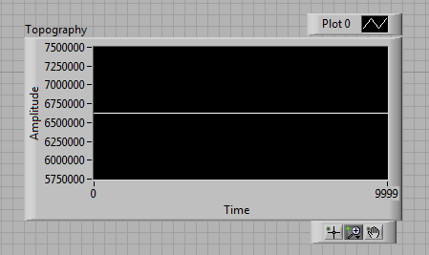

This graph gives me real time continuous data on my MCL output.

Date: 10/17/2013

Entry: More Problems with the Approach Retraction Program

Looking at the topography graph above, I did not have user control over this graph. I pressed the MCL Counter Control button but nothing was moving or changing. This control button actually controls the amount of voltage input for the MCL piezoelectric.

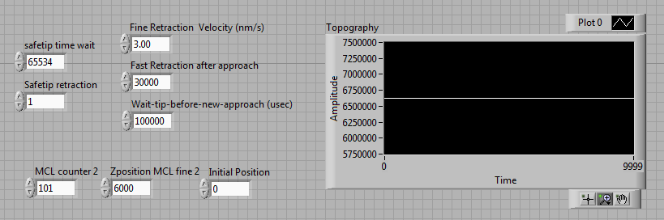

The arrows point to the user controls of the MCL to control the voltage being supplied to the MCL piezoelectric. The MCL counter 2 is the main "stepping" voltage where the voltage is controlled through specific voltage jumps. The Z position MCL fine 2 is essentially fine or intricate control of the expansion or contraction of the MCL. Before the program start, the Initial Position control will position the probe at that position. This position is described similarly to that of the Z position MCL fine. The problems I faced were not being able to really get the topography graph working. I analyzed the program to see if there any mistakes but the program was correct. I then had a suspicion that the error was in the hardware and wiring implementations. I completely missed a crucial part of the MCL driver which was the power supply. I never connected the power supply to the SANM connections so the signal never ran to the MCL. The power supply is crucial because the LabVIEW output for driving the MCL comes from the FPGA. The main problem with the FPGA is that it outputs a noisy electric signals. I am approaching a probe on the scale of nanometers and angstroms so having noise can slightly shift my probe by ones or tens of nanometers and that would be deadly. The power supply amplifies the signal of the FPGA and cleans out the noise. A picture of the power supply below.

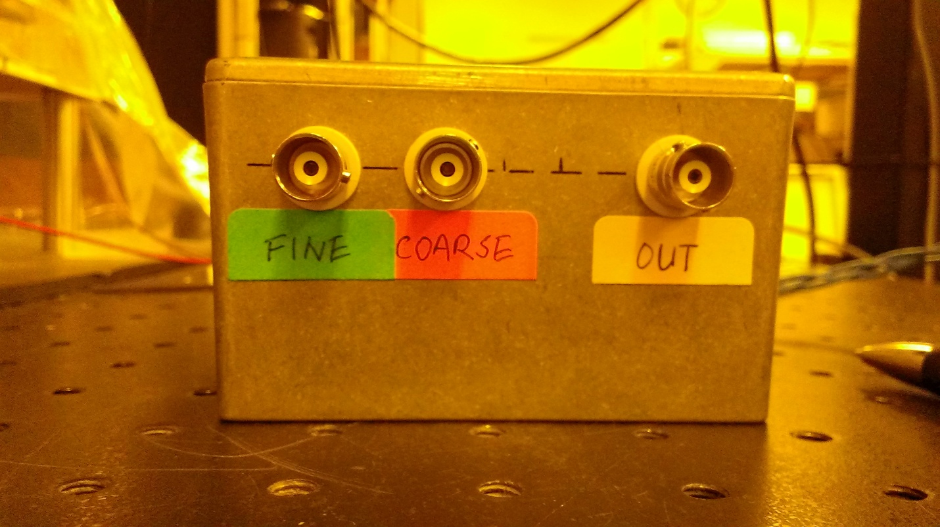

Date: 10/24/2013

Entry: Initialization of the Approach Retraction Program

So today, I finally got the approach retraction topography graph to work and I now have full control over the MCL. To be safe I placed the tip pretty high on the approach/retraction stage and drove the tuning fork at the resonance frequency. Once done, I made sure that all the FPGA connections are correct. As one of the key parts of the approach/retraction stage, the FPGA pin connections are very important. These pin connections are made inside a breakup box where the FPGA circuit contains outputs and inputs that are both digital and analog. The connections of the breakup box are shown.

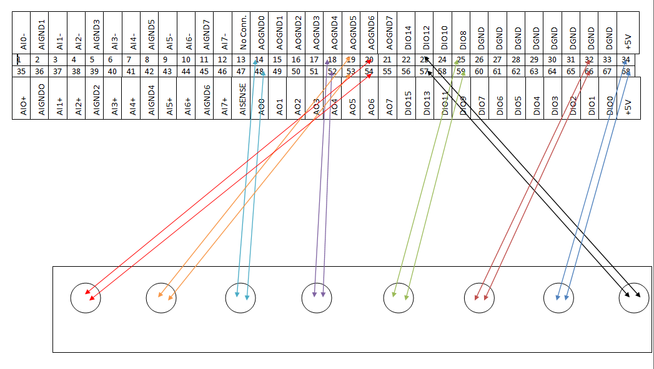

The box on the right shows all the 68 pins of the FPGA. These consist of both digital and analog pins and it is very imperative to correctly connect the pins. Almost every pin on the FPGA circuit is also accompanied by a ground pin. The box on the left has several holes with two arrows accompanying each hole. The holes represent BNC cables that are connected and each BNC cable carries a certain signal for a specific part of the approach/retraction stage. During the initialization stage, I made sure all the connections were made and each machine is working

Date: 10/25/2013

Entry: Testing the Approach Retraction Stage

Today was the day I was really excited for. All the work I put into the approach/retraction stage might pay off. I started up the program, MCL, Lock-In Amplifier, FPGA, and the power supply. I made preliminary tests for each machine to make sure the functionality was performing to the expected standards. I started the tip pretty high up and I did a manual approach/retraction. As I was doing these tests and I got really close to the mesoscopic fluid, I could see the amplitude component of the SR-850 flickering as I approached the surface-liquid interface or penetrated the liquid. I manually approached using the step size and once I saw a reduction in the signal of 90 units, I switched over to the fine control. I had voltmeter hooked up monitoring the voltage of the MCL output and the MCL fine has accuracy on the control of 5 millivolts. I started to see flickering and the deeper I got, the tuning fork amplitude reduced. I stopped at when 30% of the original amplitude of the tuning fork reduced. Throughout this whole operation, I could see the fluctuations of the acoustic sensor and the acoustic sensor has the opposite signal of the tuning fork. For example, if I penetrated the liquid and the amplitude of my tuning fork dampened, the signal of the ultrasonic sensor would be pretty high. I was able to gauge how deep I was going from monitoring the acoustic and tuning fork signal. Overall, it was a good day.

Below is a picture of the whole approach/retraction stage:

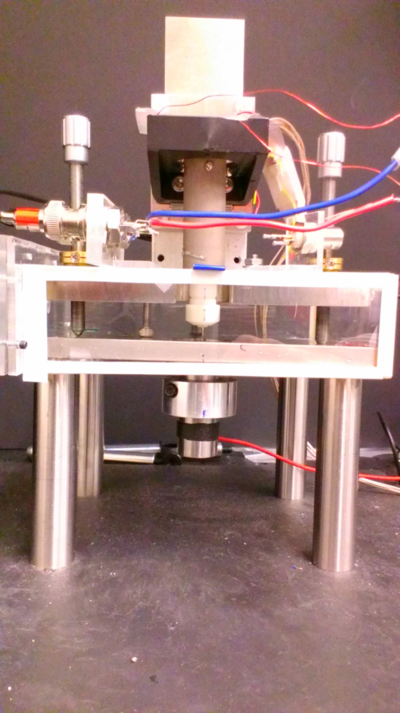

BNC Cable

MCL Stage

Acoustic Sensor

Probe= Tip + Tuning Fork

Date: 11/5/2013

Entry: Introduction to Tip Fabrication

Today, I switched gears to learn the art of fabricating tips to attach to the tuning fork. I think it’s a pretty understated part of this project because it’s one of the simple parts of the project. The reason why tip fabrication is important because one my goals is to achieve very high resolution and that high resolution comes from a properly fabricated tip. This tip has to be so sharp that the last end of the tip is ideally a single atom so on the molecular dimension, it is a fabricated "atomic" tip. With a single atom, that is the only surface interacting with the mesoscopic liquid so I can accurately describe its properties. The tip is constructed through a process called electrochemical etching. Electrochemical etching is where a tip is dipped into a container of an acid or base and when an electric current is applied, the liquid eats away the metal at the liquid-metal interface. The carving of the metal wire will yield a very sharp tip on the scale of microns and nanometers.

Date: 11/8/2013

Entry: Temperature Control

Another component of SANM is temperature control. Temperature control is to simply keep more factors constant such as humidity and temperature. An added benefit is to observe the properties of the mesoscopic fluid with differing temperatures. Temperature control can be a very valuable tool because understanding the dynamics of the mesoscopic fluid due to temperature could let me and the rest of the scientific community understand how nanoscale friction works when processors and transistors start to heat up.

The heart of temperature control is the power transistor. The power transistor is like any other transistor except the heat dissipation of the power transistor is very high and can actually be controlled as a transistor device. The power transistor consists of a base, collector, and an emitter. A LabVIEW program will control the base current to manipulate the collector and emitter current. By doing that, I can effectively control how much current is flowing and thus, the amount and temperature of heat being dissipated.

Date: 11/14/2013

Entry: Tip Fabrication

Today, I set up the electric circuit for electrochemical etching and I etched my first tips today. The electric circuit for electrochemical is quite simple. The electric circuits start with the DC power supply which supplies a maximum of 15 volts. The output of this power supply is connected the metal tip. The metal tip is then dipped into the HCL container where the etching process beings. The electric current passes from the tip to the liquid. A copper ring connected by a wire is placed at the bottom of the HCL container where that ring is not in contact with the tip. The ring is there to complete the electrical circuit by connect the wire from the ring to the ground of the power supply. My first tip was etched at a voltage of 5 volts that yielded about 0.3 amps. My second tip was etched at 10 volts with yielded about 0.3 amps. The next two tips were conducted in the same procedure as the second tip. Here is a picture of the tip freestanding in the air and then penetrating the HCL liquid.

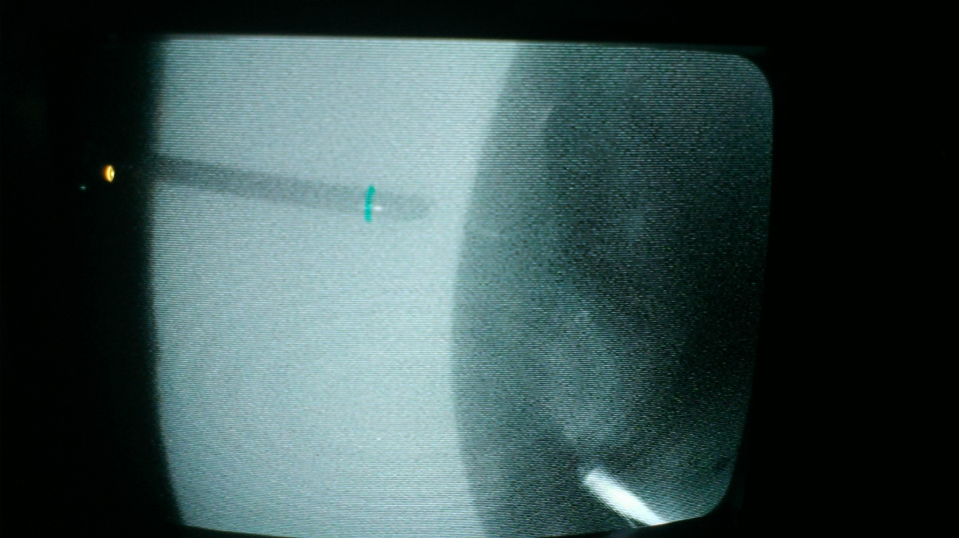

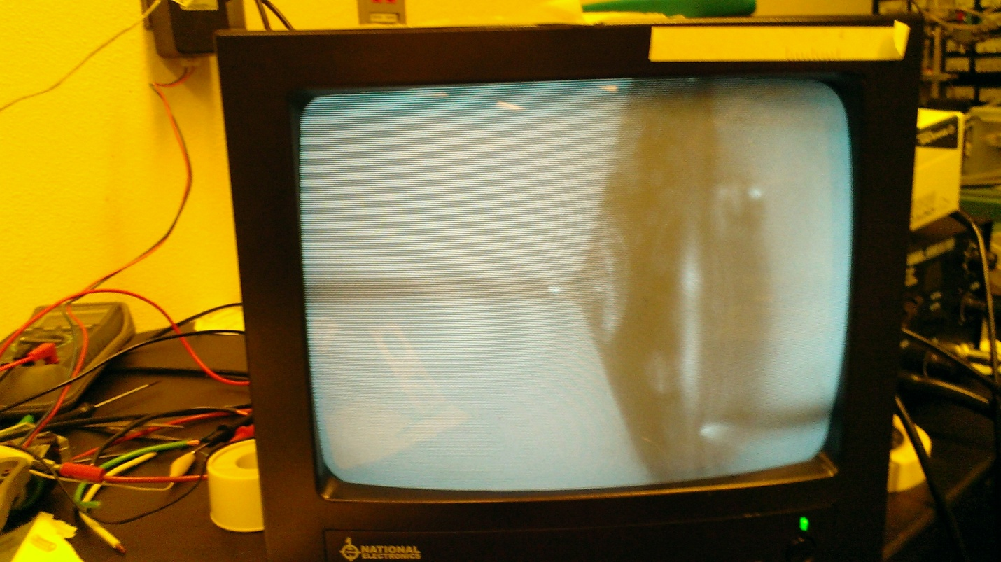

Date: 11/21/2013

Entry: Tip Fabrication

One of the graduate students under my professor said that making slightly blunt tips has huge advantage in increasing the sound of the with the acoustic sensor detecting signals in the mesoscopic liquid. With more sound generated, obtaining data becomes easier and results are easily identified.

To make blunt tips, you must be able to see the interaction between the tip and the solution. To achieve this, use a CCD camera with a particular lens and make a stand to hold the CCD camera at the exact height of the etching. Use a TV screen or computer screen to display the camera’s view and adjust the gold wire and the gold ring to be both displayed on the screen. You should be able to see when the tip hits the surface of the HCL.

Blunt tips are formed when the gold wire is barely dipped into the surface, not completely submerged. Once an electrical current passes through the interface, the HCL eats away at the gold wire. As the gold wire starts to taper and starts to become thinner, the HCL recedes and etches a smaller portion of the wire. At this stage, moving the ring up back to its original submersion into the gold wire is important. This is where a blunter tip forms. Repeating this stage multiple times gives a blunt tip.

A drop of HCL liquid

Tapered Probe

Date: 11/22/2013

Entry: Tip Fabrication Results

The next two days I attend the lab, I will purely focus on creating semi-blunt tips to sharp

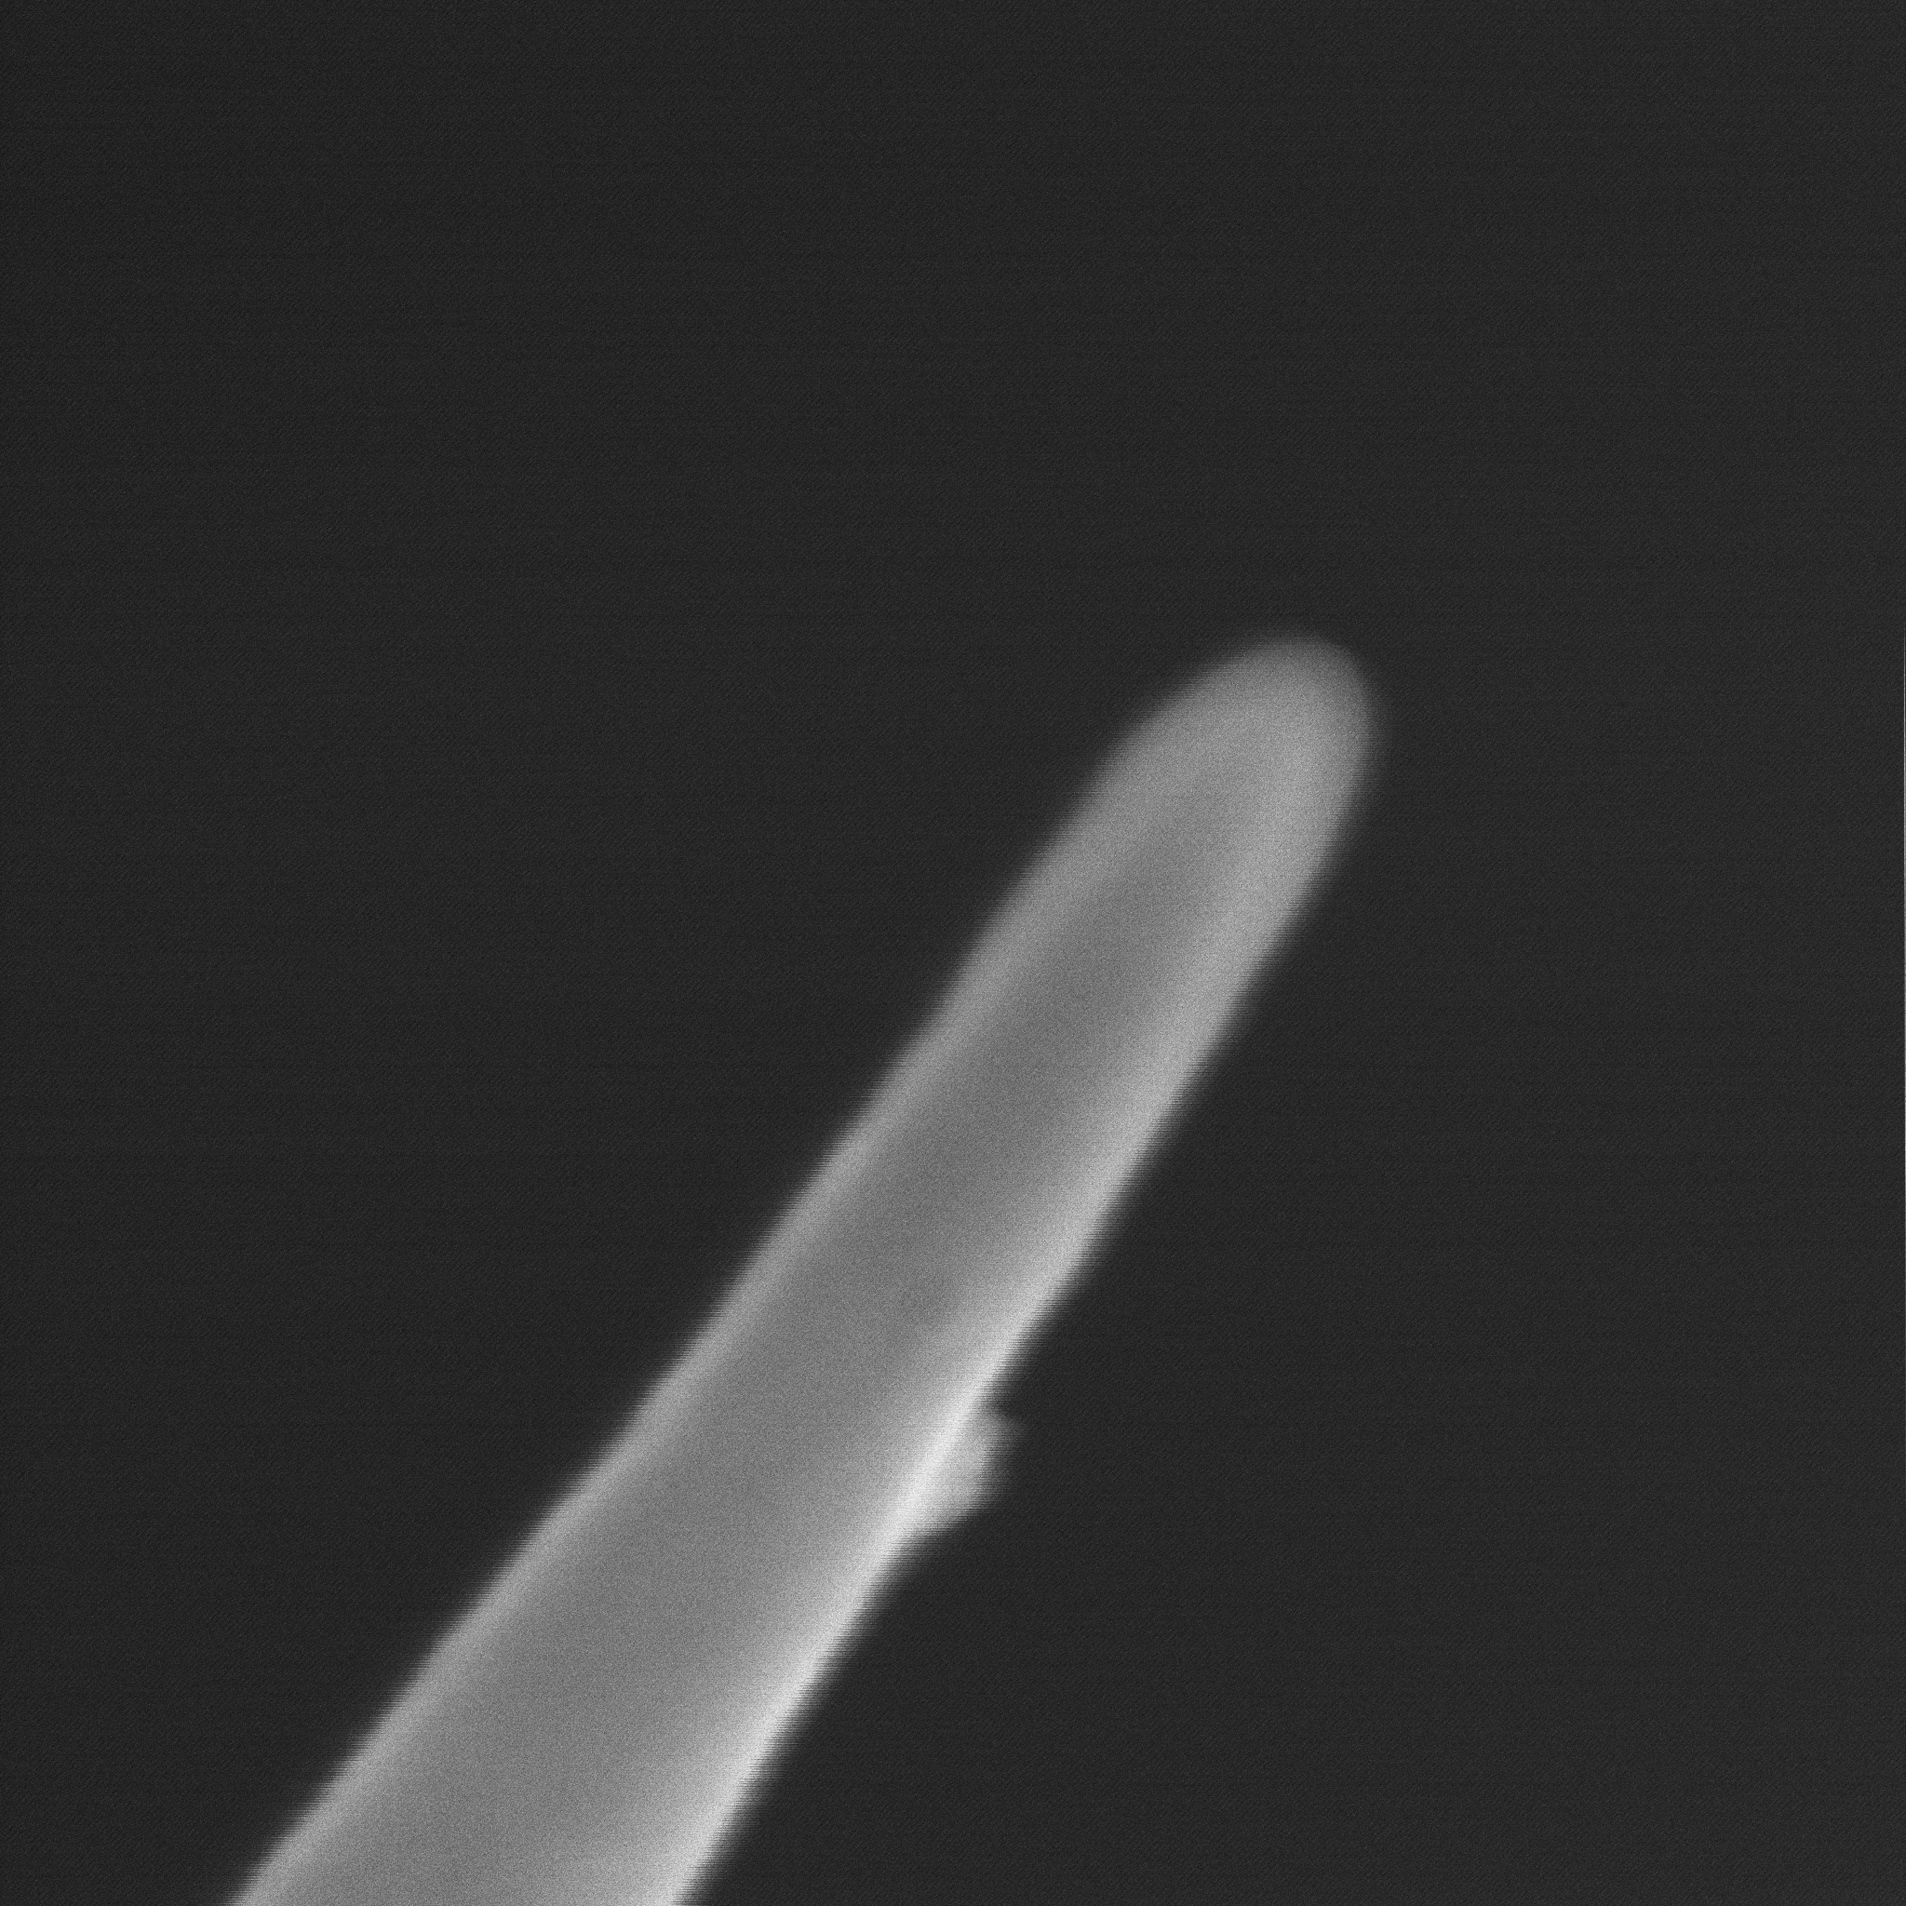

tips. I completely made these tips and then I viewed them under an electron microscope to see

the detailed images of the tips I created.

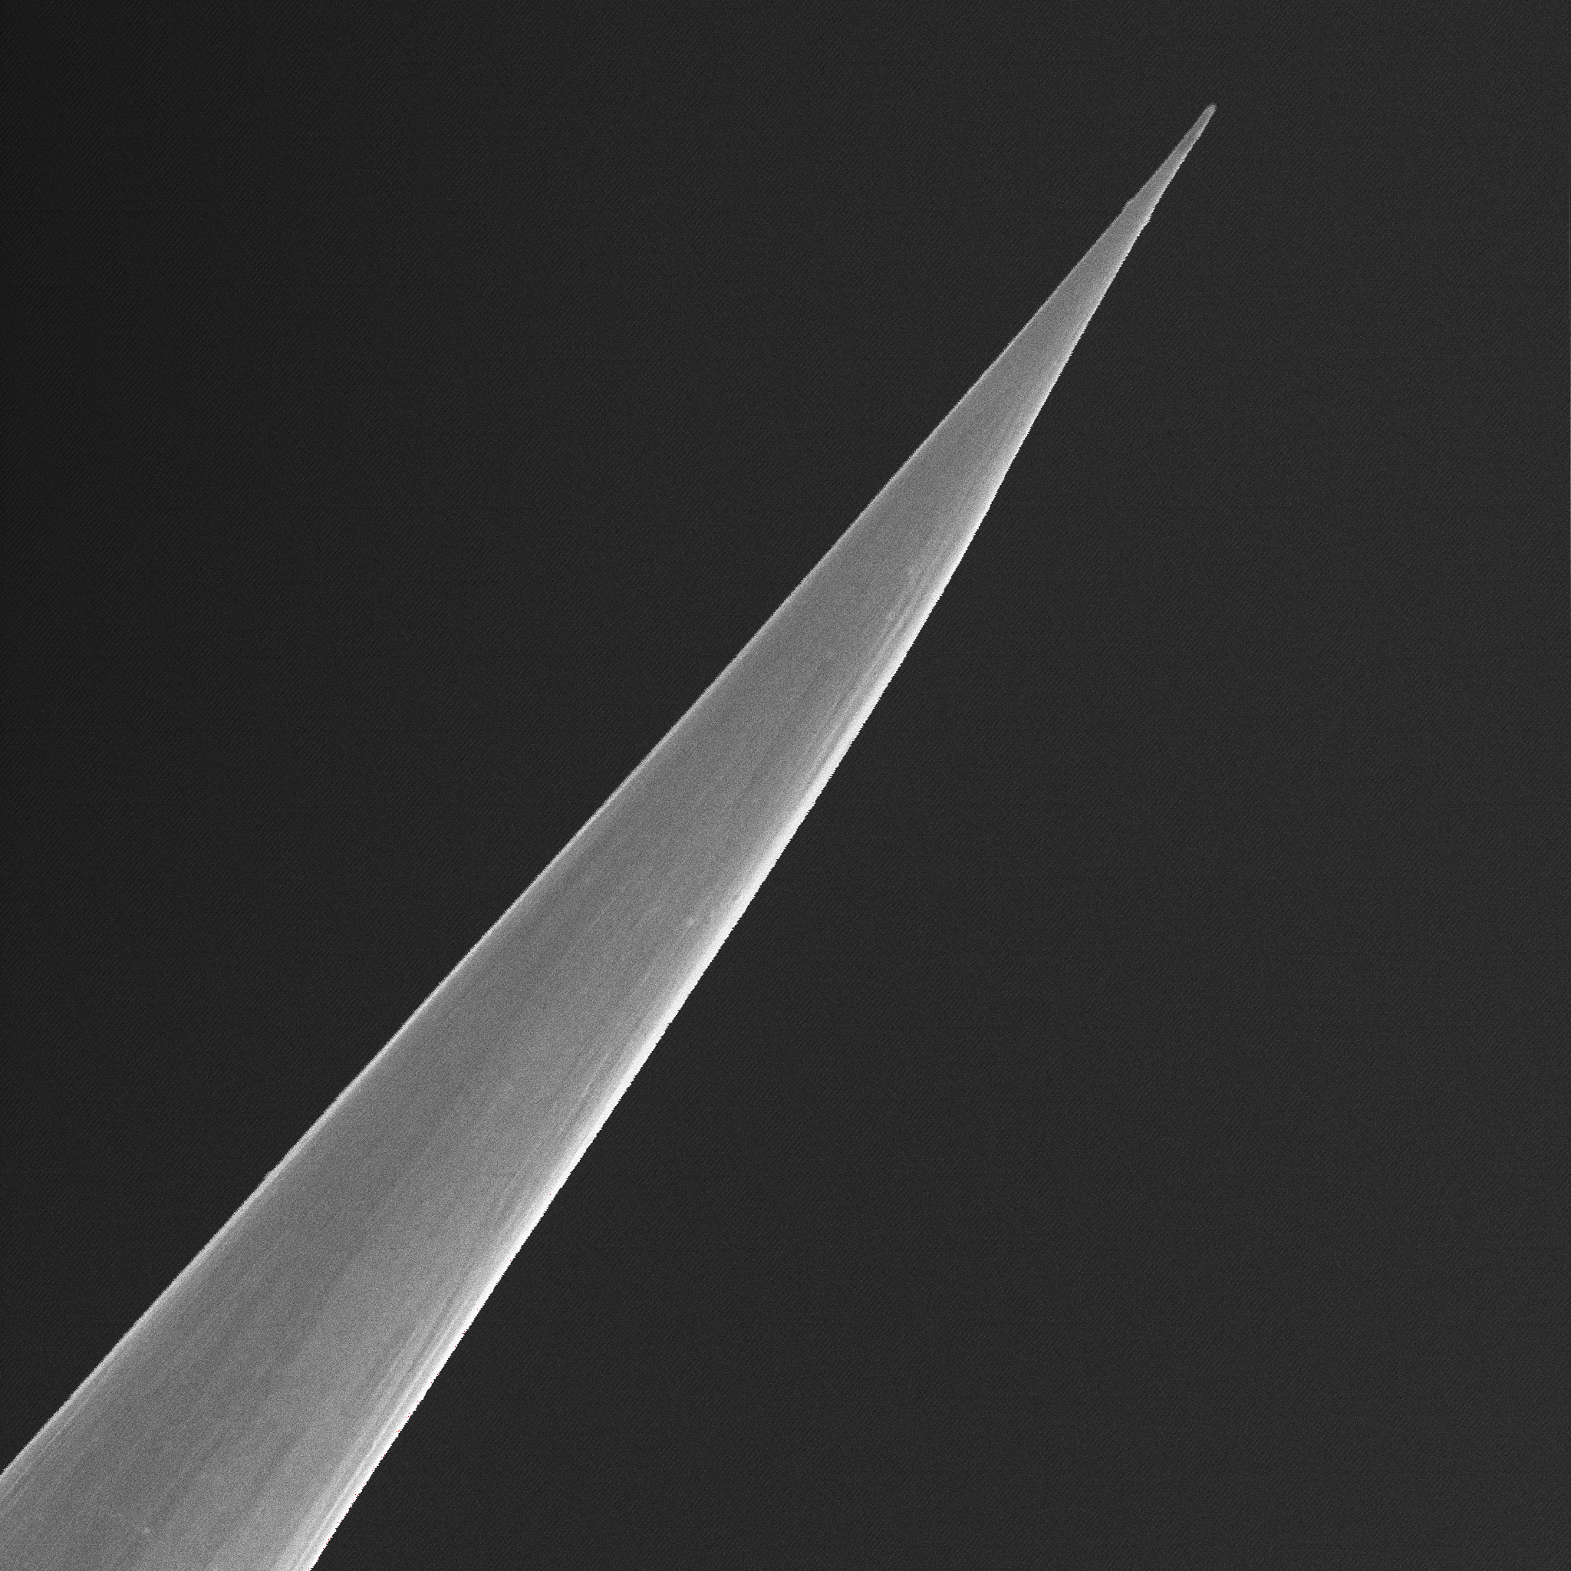

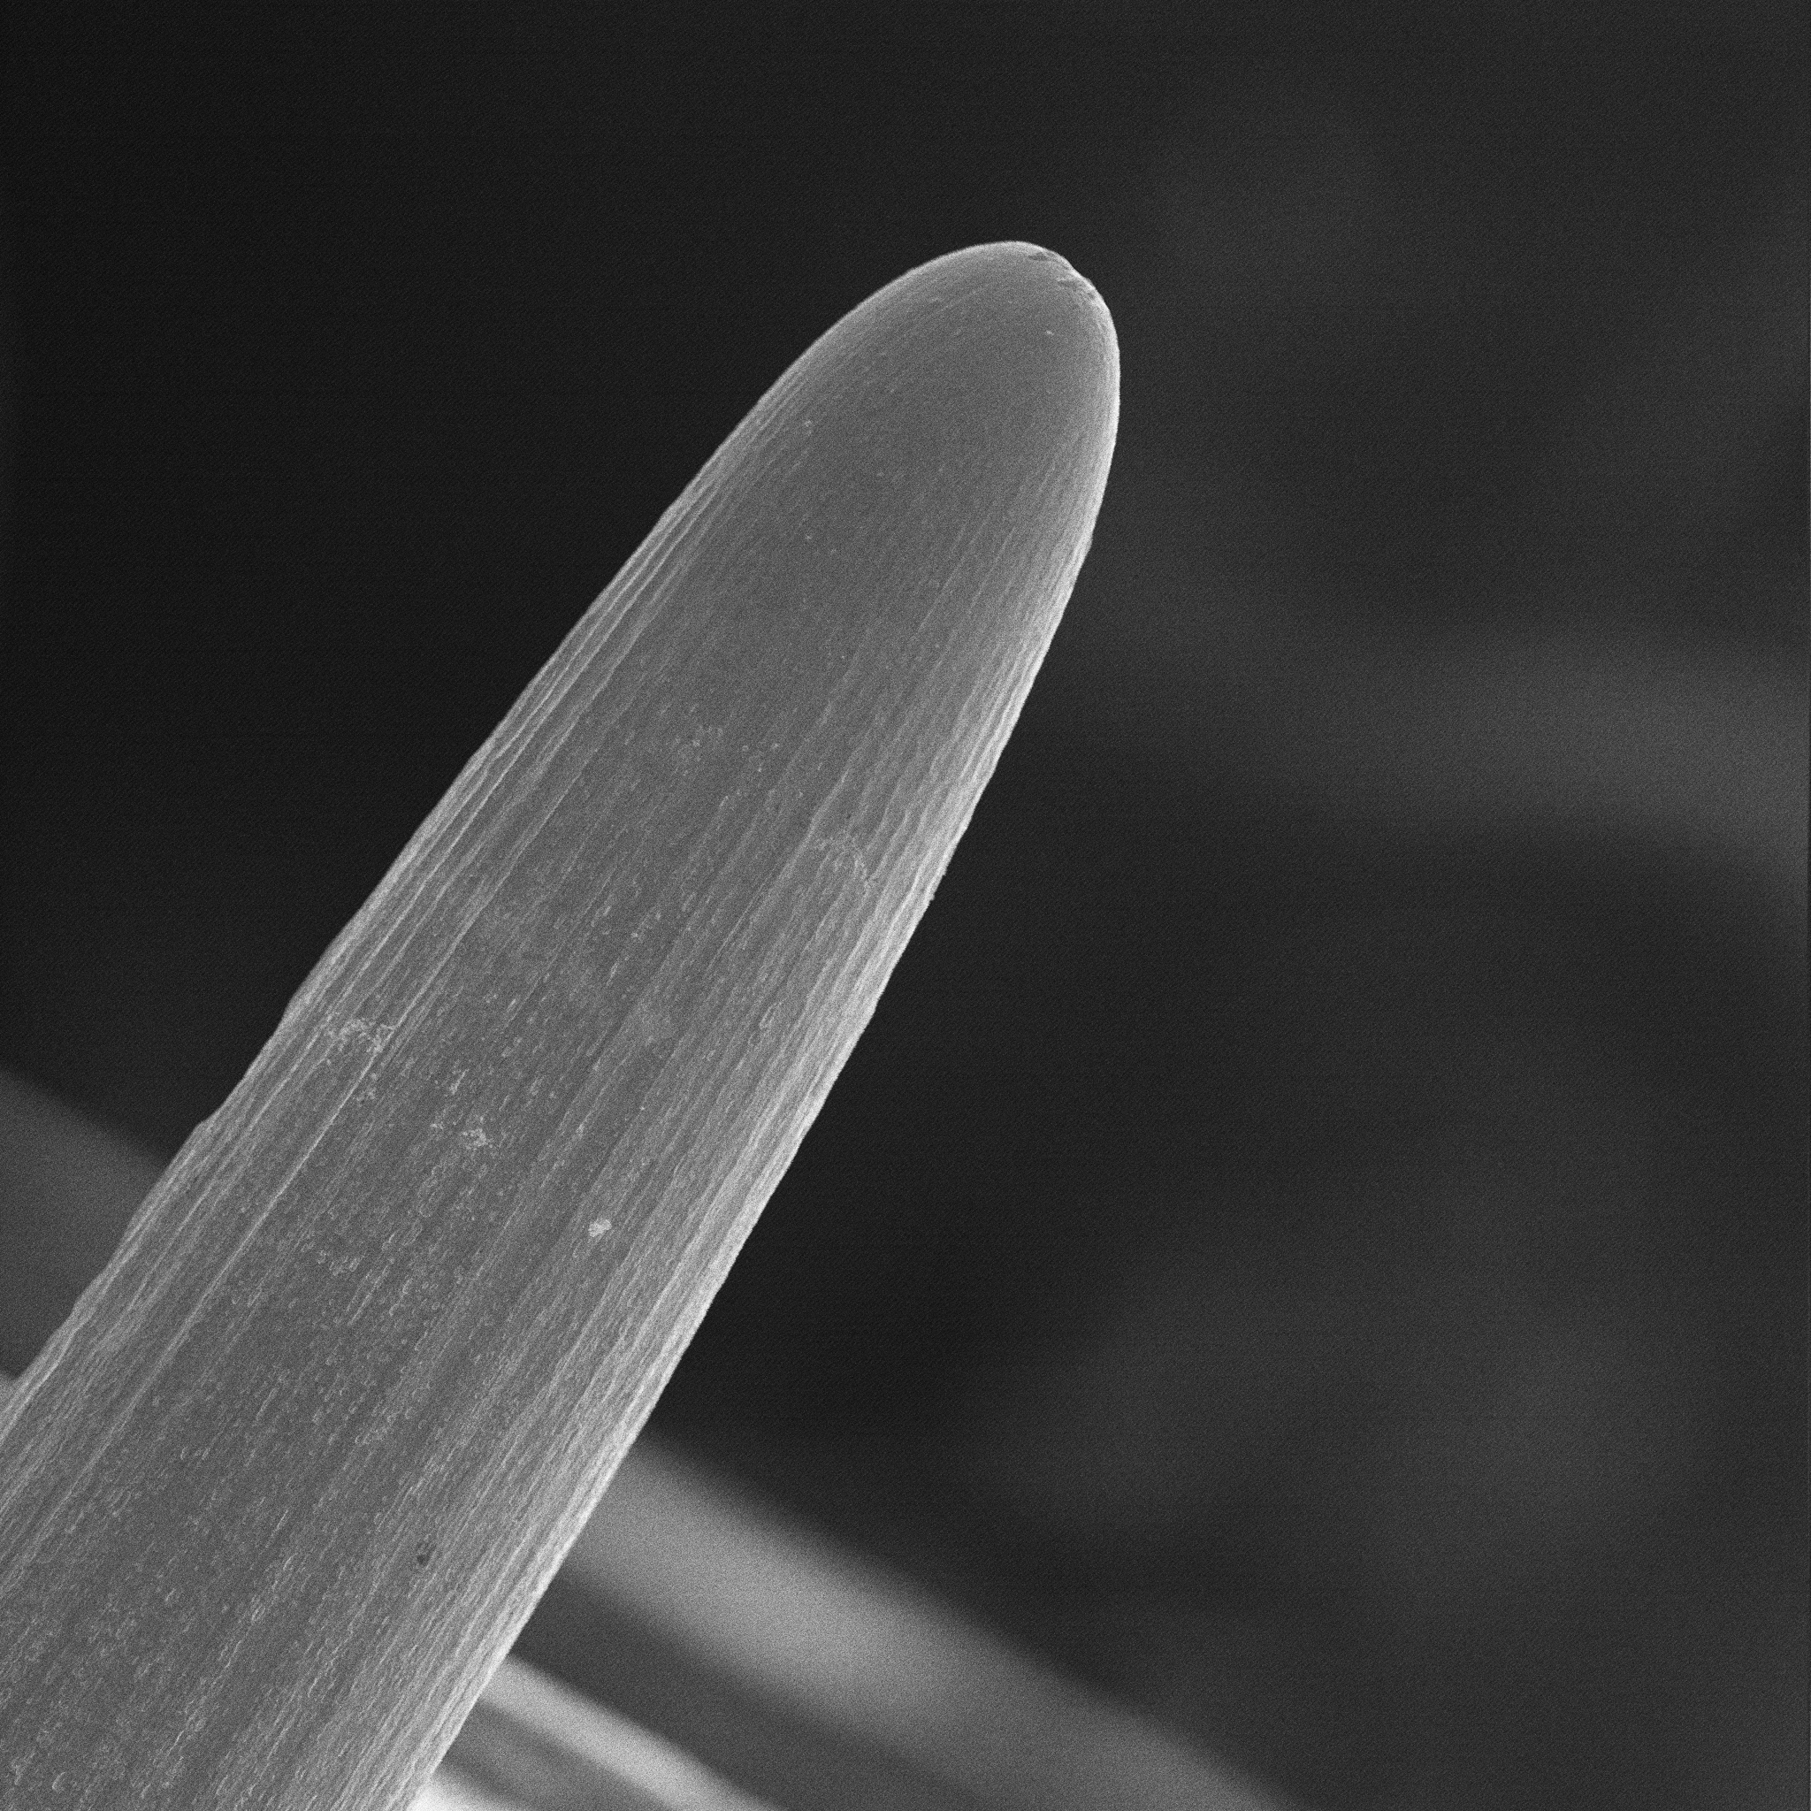

Date: 11/25/2013

Entry: Tip Fabrication Results Pt. 2

The same thing as I did on the twenty second. I made tips through electrochemical etching and then viewed them under the electron microscope.

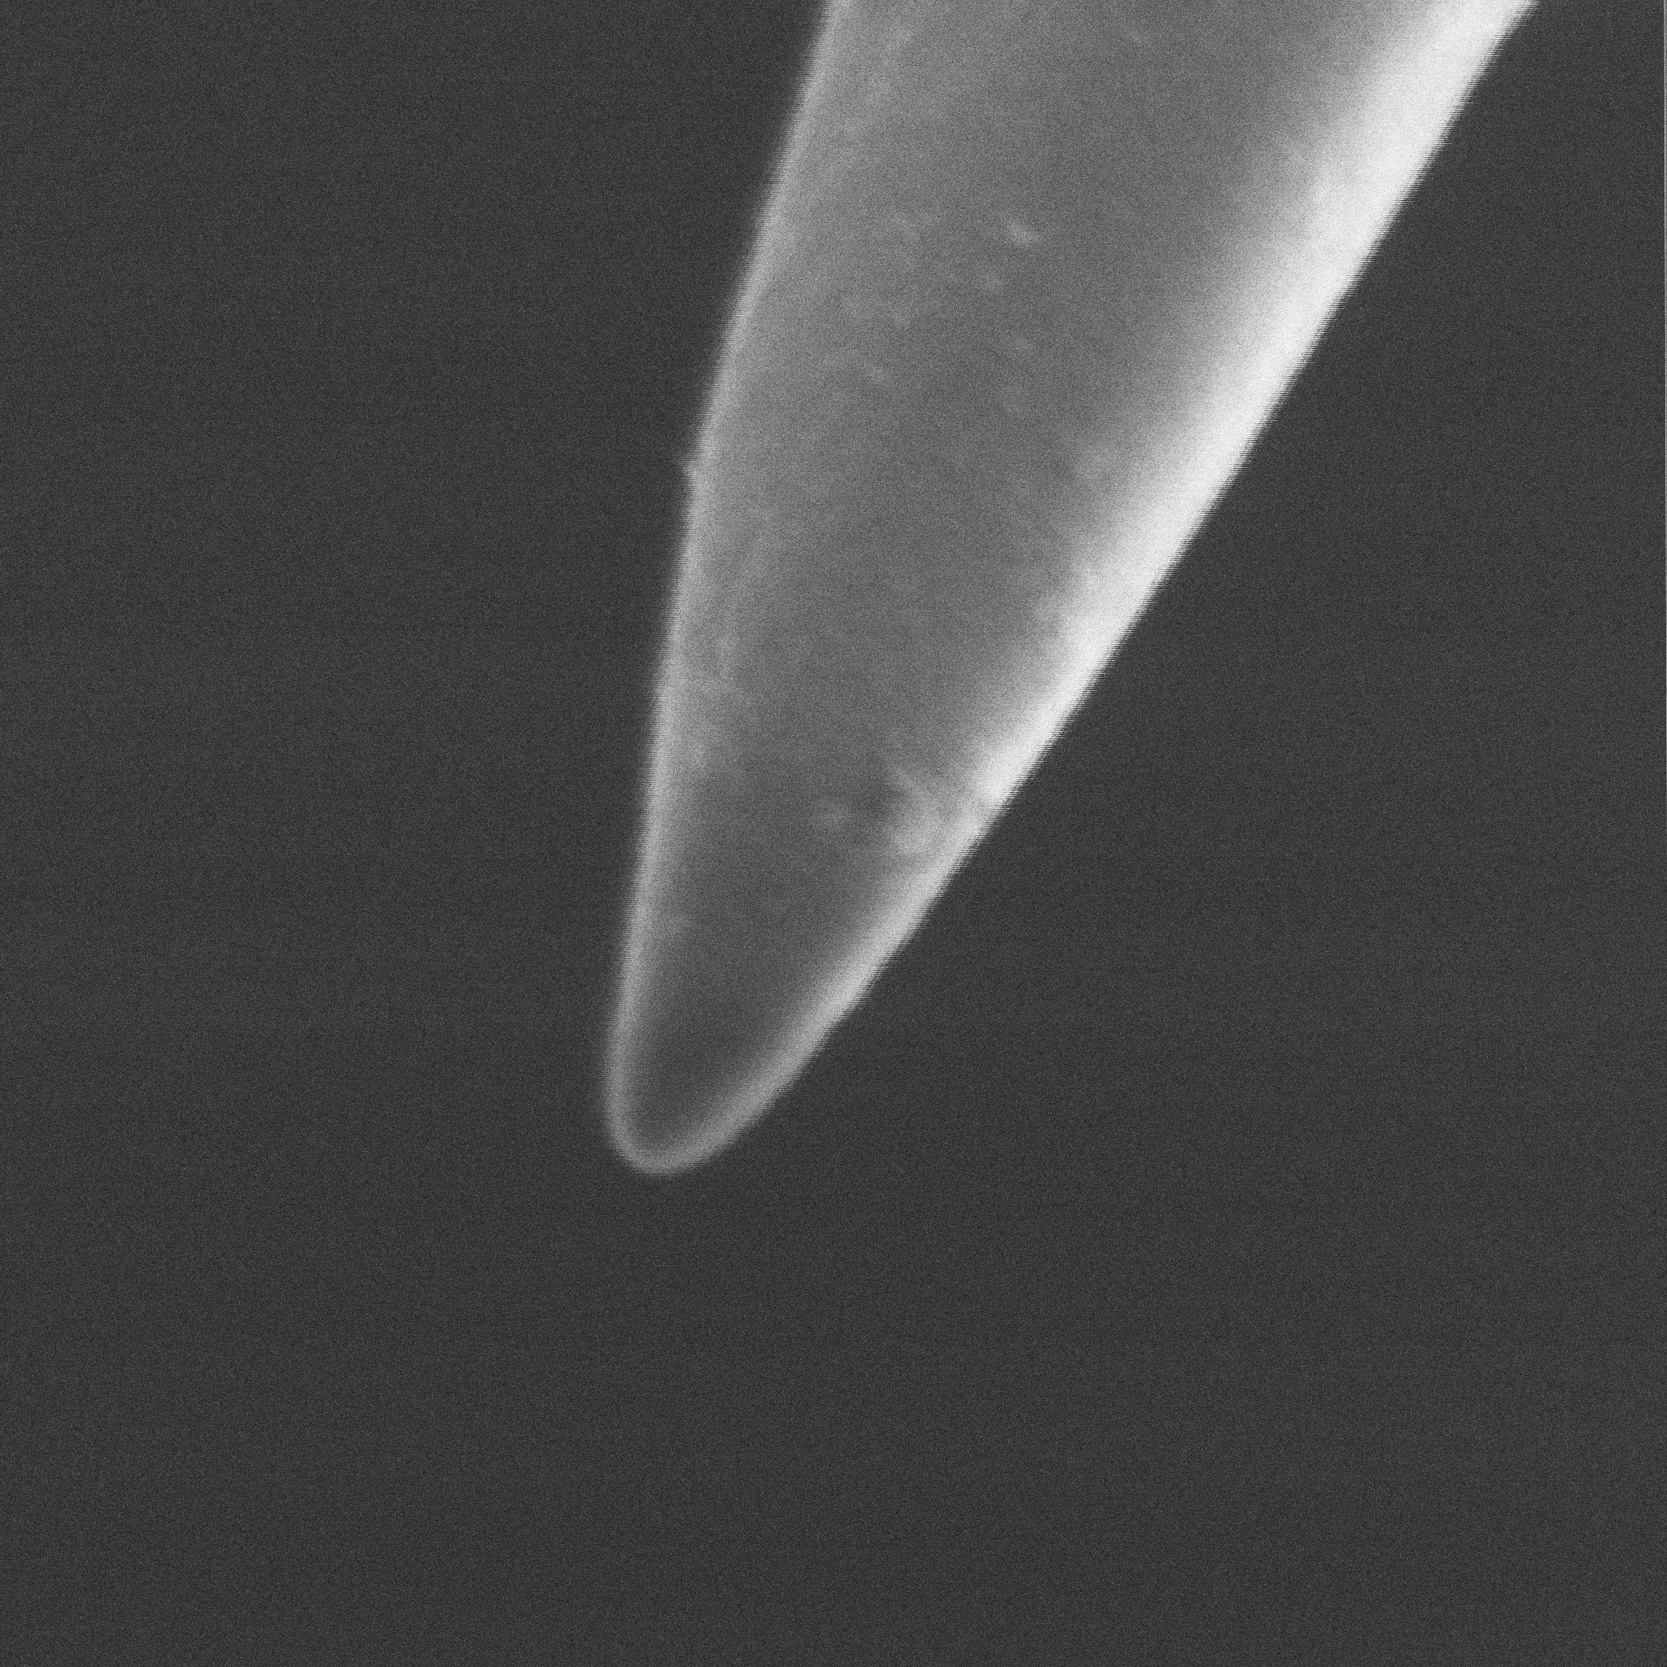

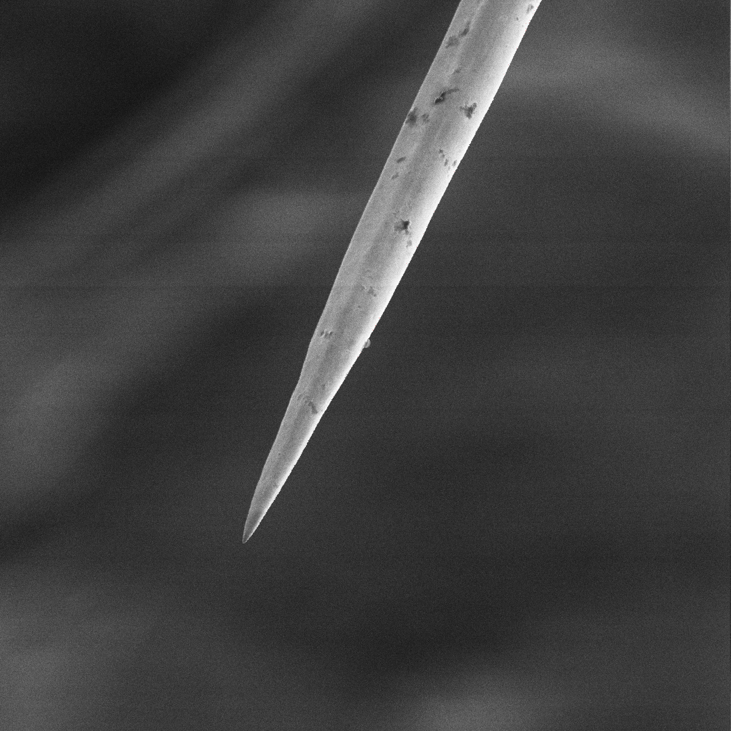



Date: 11/28/2013

Entry: Problem

Today, I wanted to conduct some approach/retraction tests of the SANM apparatus to maintain the operational capabilities. I did some preliminary tests of observing approach and penetrate the liquid. I had also read some theory about the tuning fork a while back and I remembered how the amplitude decreased if the quartz tuning fork did not vibrate at the resonant frequency. I was noticing during the tests of the approach/retraction program when I started to see the tuning fork's amplitude decline much earlier than expected and I saw random fluctuations in the tuning fork signal. I did four approach/retraction curves to see if I consistently observed these results. It then hit me that maybe the tuning fork's decrease in amplitude was not entirely due to the damping effect of the mesoscopic liquid. I noticed that there were two noticeable factors in the decrease in amplitude. Environmental fluctuations regarding temperature and humidity could definitely throw off the amplitude of the tuning fork and I realized that if these environmental fluctuations threw off the amplitude of the tuning fork they could definitely change the resonant frequency. The resonant frequency depends on the spring constant and mass. With resistance from the liquid and environmental fluctuations placing stresses on the tuning fork, the resonance frequency will definitely shift. This alarmed me a lot and I realized that I could not continue on my original goal of SANM tests with temperature control. Immediately, I talked to my professor about the potential problem I discovered and he had suspicions that maybe they were profound factors in affecting the tuning fork. I discussed with him for a lengthy amount of time and out of that discussion came the technique of frequency modulation. My job was clear: use frequency modulation to correct the problem.

Date: 12/19/2013

Entry: Frequency Modulation

Frequency modulation is quite frequently used in the electronic world. Frequency modulation is most often used in FM radios and Digital Signal Processing. In my case, I will be using it to maintain a ninety degree phase shift between the input and output signals. I know that if a 90 degree phase shift is maintained, then the resonance frequency of the tuning fork is guaranteed and that will yield the maximum amplitude of the tuning fork. I believe that once the tuning fork is always vibrating at the resonant frequency, that will yield maximum amplitude regardless of the interactions at the probe-liquid interface. Frequency modulation consists of three stages which comprise of the PLL. The PLL is the heart of frequency modulation. The Phase Locked Loop contain another mini PLL (Lock-In Amplifier) and these two PLLs make up frequency modulation. The mini PLL contain a multiplier, a reference signal generator, and a filter. A reference signal is hooked up to the first PLL and it flows into the reference signal generator. The reference signal generator itself consists of a multiplier, PID, and a VCO. The VCO at the start of the program outputs a frequency and voltage at the nominal setting. This frequency and reference input are multiplied together. Once the multiplication happens, two sine signals are the result. One of the signals contain a phase difference and the other signal contains a phase addition. The sine function with the phase difference is the key. Then the phase goes to a PID with a set point where the set point is set to 0 degrees. The reason why the set point is 0 because the Lock-In wants to create its own reference that matches the external reference. By doing this, the Lock-In identifies the frequency, phase, and amplitude. If the phase between the VCO and reference is 0, then the frequency of the VCO and reference is the same. Frequency and phase are interrelated. The error from the PID controls the VCO to make it match the frequency of the reference signal. After the reference signal generator phase, the internally created reference is then multiplied to the input signal of the first PLL or the Lock-In Amplifier. This multiplied signal is then run through a filter to extract out the phase difference. This PLL continuously runs to ensure that the reference signal created matches the external reference.

The second PLL is the main component of frequency modulation. Since the first PLL knows the frequency, phase, and amplitude of the input signal, the second PLL takes the phase and runs it through the same process of a PID and a VCO. The set point here is ninety degrees because this ensures the resonance frequency of the tuning fork and maximum amplitude. The VCO then follows in suit to drive the tuning fork at a frequency dictated by the PID error.

2nd PLL

Input Signal

PID Microcontroller

Filter

Multiplier

External Reference

VCO

1st PLL

Date: 12/20/2013

Entry: Lock-In LabVIEW program

The first step to implement frequency modulation is to create the Lock-In Amplifier on LabVIEW. I need to translate the theory of the Lock-In Amplifier into program functions and implementations. So I created a fairly simple LabVIEW program that resembles the Lock-In Amplifier and is very simple to the picture in the previous day.

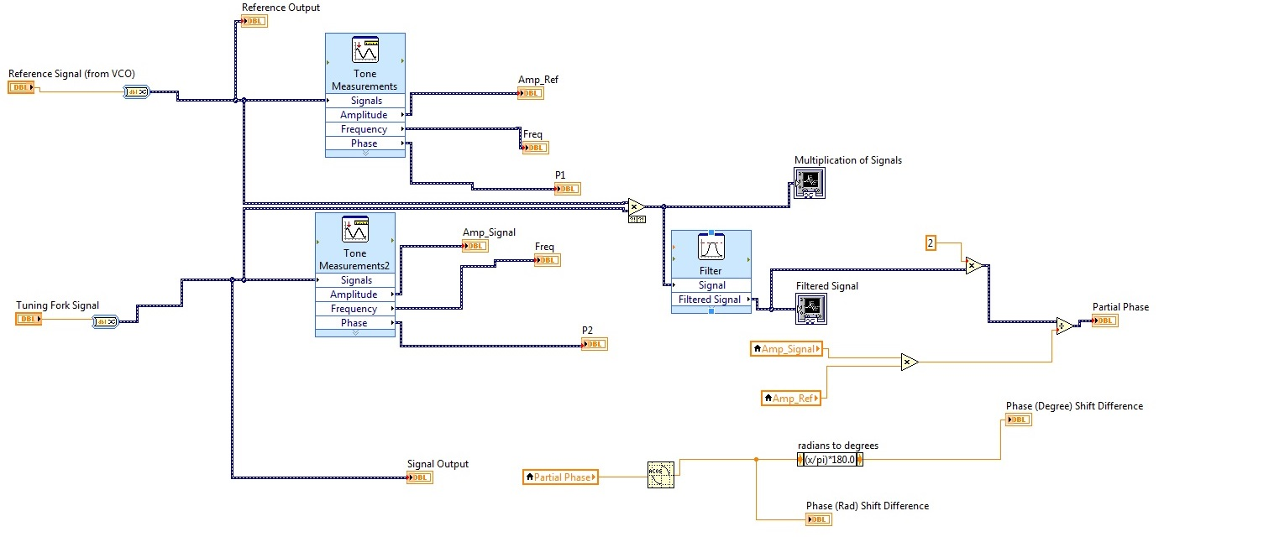

The program contains the reference signal, tuning fork signal, multiplication of the two signals, filter of the two signals and the calculation of the phase difference. But, I am programming on the FPGA so I need modify the Express Signal functions (big blue program functions) because they are not the most efficient implementation on the FPGA. The program shown here is the

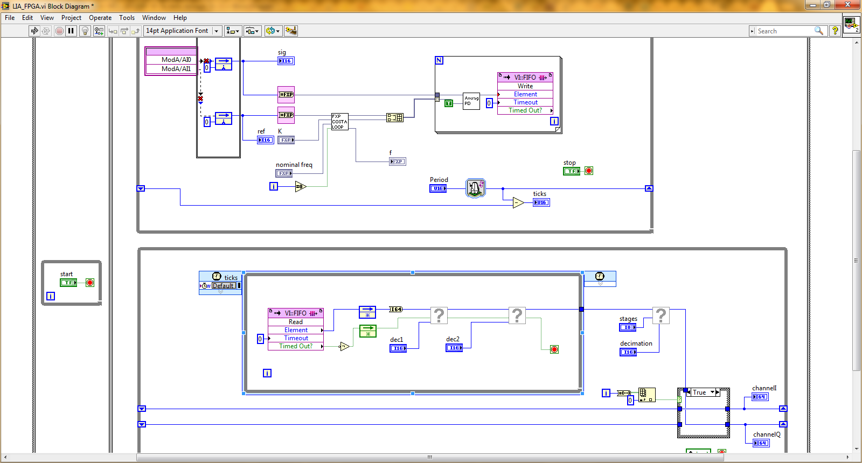Lock-In Amplifier implementation on LabVIEW using the FPGA. The program shown below

was provided by the lab with modifications made to the program by me. The program works in similar fashion. The blue I16 indicators on the top left show the reference and input signal. The reference goes through a PLL and the program internally creates its own reference. The signal is then multiplied to the internal reference. The resulting multiplied signals are sent through a filter in the second while loop.

Date: 12/21/2013

Entry: Understanding the Lock-In functionality

Before I can move to the next steps of the implementing frequency modulation with the approach/retraction method, I need to find a way to implement both programs with the current hardware and software limitations. The FPGA has limited space so I have to find a way to incorporate both programs. Today, I designed a plan to run both FPGA programs. I planned to install a second FPGA because I tried multiple times to compile the target program but the file was too big. I asked my professor and a second FPGA was implemented into the desktop of the computer.

Date: 12/22/2013

Entry: Ordering components and installing the second FPGA

I learnt of other things I need to do in order to provide the functionality of both frequency modulation and the SANM program. I need both FPGA PCI cards to communicate with each other because frequency modulation will be driving the tuning fork and the data from frequency modulation must be sent to the SANM program so it can track the changes in the tuning fork amplitude. So I talked to my professor and ordered a cable called the RTSI cable. The RTSI cable provides communication between multiple FPGA cards simultaneously while they run. The list of components that I had gathered the other day is also now ordered from eBay. To test the functionality of Lock-In Amplifier, I downloaded the Lock-In host. I compiled the target program and observed to see if there was any errors. There were not any errors so I setup the SR-850 to output a sine wave at a certain frequency. Then I looped this wire back to the SR-850's inputs. Then, I used two BNC cables to extract the output and input of the SR-850 and connected them to the FPGA. The FPGA was working as the digital Lock-In was able to correctly hone on the frequency given by the SR-850.

Date: 12/23/2013

Entry: Lock-In Functionality and planning for the PID and the VCO

Once I got the functionality of the Lock-In Amplifier on the LabVIEW program, the next steps were extracting the phase from the LIA and plugging that into the PID and using the error to drive the VCO. The output of the VCO is connected to the tuning fork to drive it at the resonance frequency. For the PID, I realized that I needed to calculate the error from comparing the measured variable to the set point and then run that error through multiple mathematical operations such as the integral and derivative. Once I calculated the PID error, that had to be sent to the VCO. Depending on the error output, the VCO will adjust the frequency accordingly. I completely finished my plan for implementing it into a program.

Date: 1/2/2014

Entry: Beginnings of Frequency Modulation Program

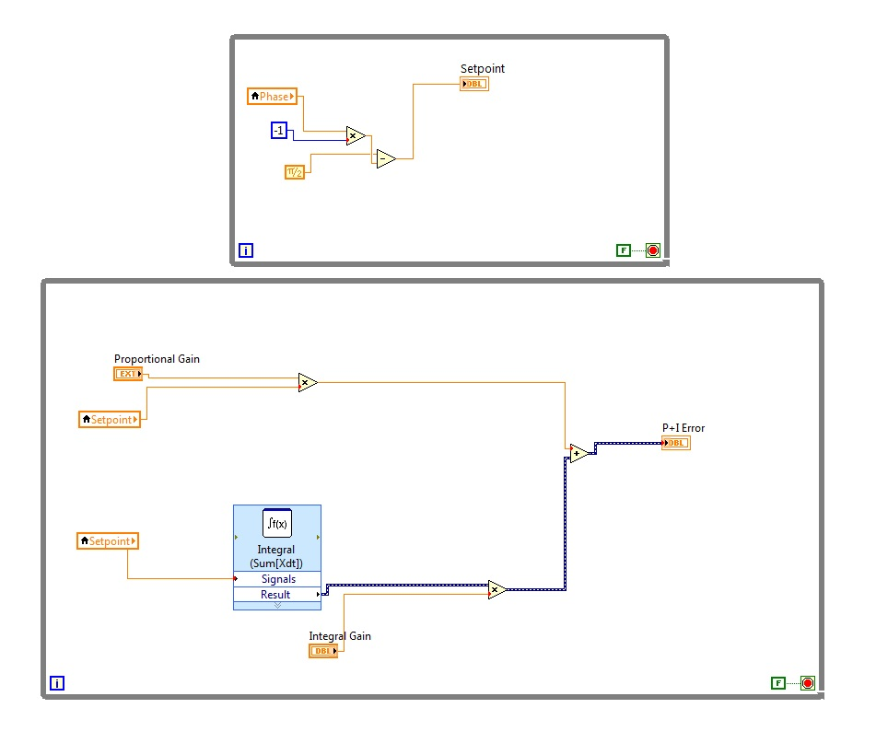 Below are the programs I for the PID and the VCO. I need to make these two programs to corporate to achieve my job in frequency modulation.

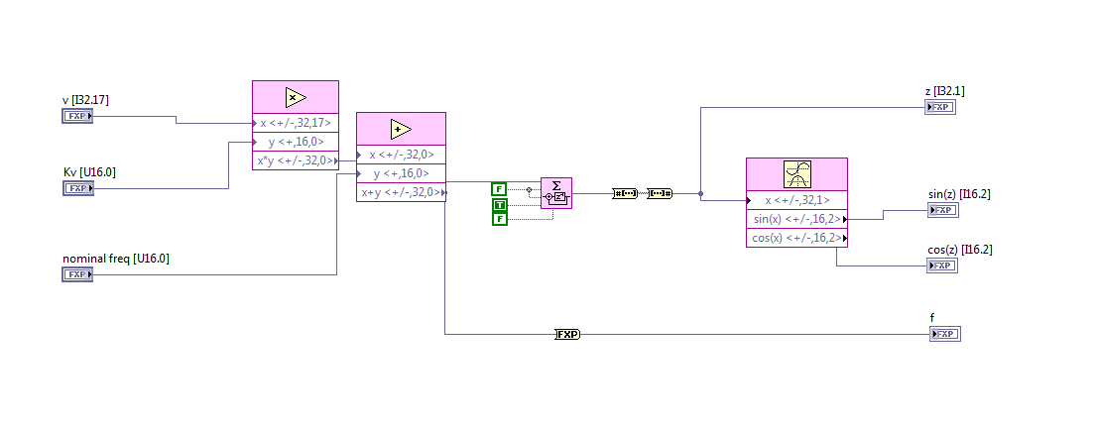

The VCO's job is to increase or decrease the frequency based on the PID error output. The VCO takes the PID error output and multiplies it by a proportional constant. This multiplication is added to the nominal frequency or the starting frequency of the VCO. This addition is the new frequency. In order to get radians, the integral of frequency is needed. The relationship between radians and frequency is that the first derivative of radians is frequency. So taking the integral of the radians yields the frequency. Then, a signal is created by taking the cosine or sine of the calculated radians. The sin(z) and cos(z) indicators are the internally created reference by the Lock-In or in the case of the second PLL, the driving frequency of the tuning fork.

Date: 1/3/2014

Entry: Installing Components and Building the Program

I got my order of the components I had ordered to build the hardware side of the FPGA program. I installed the RTSI cable by removing the desktop and placing the connection between the two FPGA cards. On the top, I placed the pins of the FPGA inside the breakup box and hooked up all the connections. I connected the FPGA cable from the breakup box to the FPGA PCI card inside the desktop. Then I ran some tests from NI MAX to ensure the second FPGA is properly working.

Date: 1/27/2014

Entry: Testing of Frequency Modulation

Today, with all the components in place and working, I proceeded to make the frequency modulation program. My target program consisted of the Lock-In Amplifier, PID, and the VCO. I essentially placed the individual while loops of the program all into one big program. I tried to compile the program but the target program exceeded the FPGA storage by almost 70%. I then figured I could then place the PID and the VCO as subVIs and this compressed the target program. I compiled this program and it successfully fit it into the FPGA.

PID

VCO

Lock-In Amplifier

Date: 1/28/2014

Entry: Testing of Frequency Modulation, Running into Problems

Today, I ran into many problems today. Error wise in terms of program functions, I fixed them all but the program was simply not running at all. I was not getting data on the graph and the program was unresponsive. At this point, I had no idea what was going on. I did a complete hardware and software check but I could not find any mistakes. Then, I tried to change the program by removing elements of the PID and VCO and recompiled the program multiple times on the FPGA target. I found no solutions.

Date: 1/29/2014

Entry: Testing of Frequency Modulation, Running into Problems Pt.2

The same story as yesterday. I still faced the same problems and I had no idea what was going on. So I started from the basics and tested the Lock-In Amplifier. I ran tests of just the SR-850 and tests with frequency sweeps on the tuning fork. The Lock-In host by itself was running properly. The frequency modulation program on which I based the program on, was not functioning at all. So then, I tested the PID and individually it completely worked. Same operational tests on the VCO and I saw that the VCO was reactive to the changes. The individual parts were working but together the parts were not harmonious.

Date: 1/30/2014

Entry: Testing of Frequency Modulation, Running into Problems Pt. 3

I am kind of getting frustrated because at this point, I think I have done almost everything to see what the problem was. I was not getting anywhere and I could not find the solution. So I started from the target program and worked my way inside-out to the host program. I isolated the target program and wanted to check if the functionality was happening. The FPGA program was getting stuck. The program got stuck because the subVIs implemented in the program had while loops that were going on forever. If these while loop don’t end, the data never goes on to the next stage and it delays the whole program. I removed all the while loops and placed a while loop in the target program instead of in the subVIs. Then the FPGA target program. I recompiled the target program and I was very optimistic it would work. Unfortunately, it did not. So I reverted to looking at the forums of the FPGA. I found that I needed to force the FGPA VI to run in order to collect data and send the data to the host. If the FPGA VI does not run, no data is sent to the host. So I forced the FPGA to run by first clicking the execute button on the FPGA program and then running the host. The frequency modulation finally started to operate have data flow in.

Date: 1/31/2014

Entry: Different approach

With my hopes pretty high, I am feeling pretty optimistic that I have successfully implemented the frequency modulation program. I started the program and I wanted to observe if the program is able to lock in on the resonance frequency. The frequency modulation program was not able to lock in on the resonance frequency. The Lock-In Amplifier detected frequency and the VCO output frequency were different and that should not happen. The Lock-In Amplifier should detect the same frequency as the VCO because the tuning fork does not change the frequency, it changes the phase shift. The integral parts of frequency modulation are failing when they are incorporated together. So I performed another tedious software and hardware check. I did not find any problems and I pinpointed the problem to be the Lock-In Amplifier. The Lock-In Amplifier was incapable of detecting the right frequency so that set off a chain of reactions. Without correctly detecting the frequency, the phase component of the signal is not detected. This affects the PID error because the phase component is erroneous. The PID error output misleads the VCO to change the frequency in incorrect ways. So I decided to take the action to start over by programming frequency modulation on the Lock-In host itself because it is reliable in detecting frequencies.

Date: 2/4/2014

Entry: Making the Program of the Lock-In Host and Problems

I opened the Lock-In host program and I started to build frequency modulation from there. This time, I declined my reliance on the FPGA program and relied more on the host. In my experience, I felt that the FPGA is good acquisition device but implementing big programs on the FPGA is not the most effective way to do FPGA-host programming. I implemented frequency modulation on the host and simplified the FPGA program by only using it to read input signals and output generated signals. I placed the PID and VCO in their respective order and with their respective input and outputs. I have everything locked in a sequence and ready to go. I ran the program and the Lock-In Amplifier was able to detect the frequency. But, the PID and the VCO were not acting the correct way as the VCO was erroneously driving the tuning fork at highly strange frequencies. I performed another tedious software and hardware check.

Date: 2/7/2014

Entry: Making the Program of the Lock-In Host and Problems Pt. 2

I am pretty frustrated that none of the programs I have created are working and my investment has not delivered any results. I tried to manipulate the target program by eliminating even more elements but my efforts were to no avail. In that process, I had to recompile the target program to the FPGA and it took a lot of time. I am stuck and I really do not know what to do. The interesting thing I saw was that the frequency was locked on but the phase component consisted of random values that fluctuated and did not reflect the right values. I looked into the phase in the program and there were no errors. At every step of calculating the phase, I checked each program implementation but there were no problems.

Date: 2/11/2014

Entry: A Solution that works

By this time, I have almost completely run out of options. The intriguing part is the frequency is being detected but the phase is not being detected. I talked to my professor about this and his doctoral researcher. Then, the doctoral researcher suggested checking the proportionality constants. I checked my proportionality constants and all the values were at decent levels but the K constant was quite low. My K constant was at 1.0 x 10e-5 and that is a pretty small value. I then realized what was happening. The smaller the K constant, the better detection for the frequency but the phase detection deteriorates. I needed to optimize a K value where the frequency and phase detection are optimal. I changed my K value to 0.0010376 and I started to see the phase and the frequency fixed. My Lock-In Amplifier finally detected the frequency and phase with great accuracy and the PID and VCO in turn succeeded in operation.

Date: 2/14/2014

Entry: Frequency Modulation

The next step for data collection is to add data acquisition and storage devices to the frequency modulation program. I placed about five data collecting devices and implemented them in the program. They are shown below. 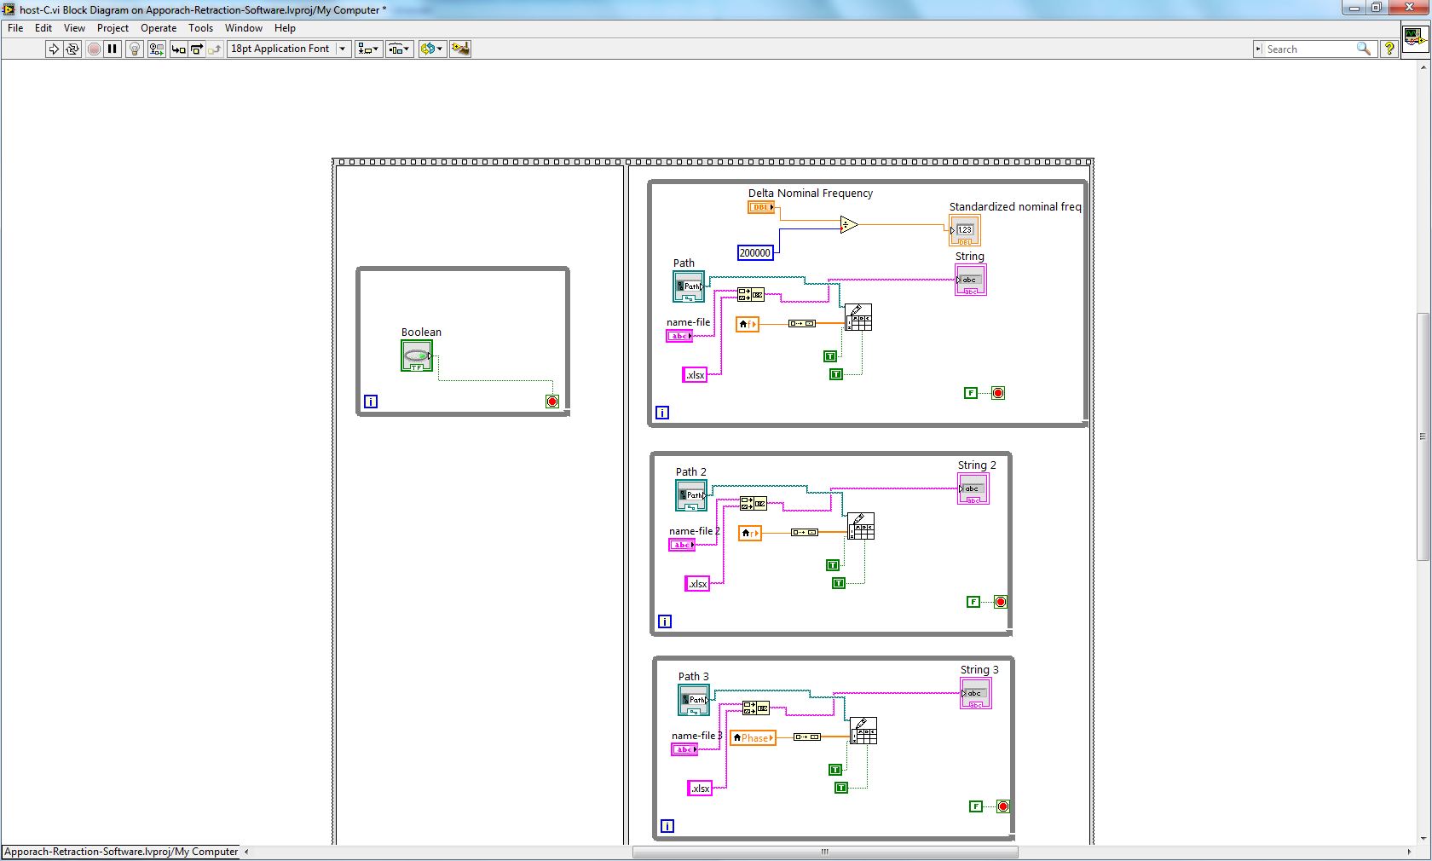

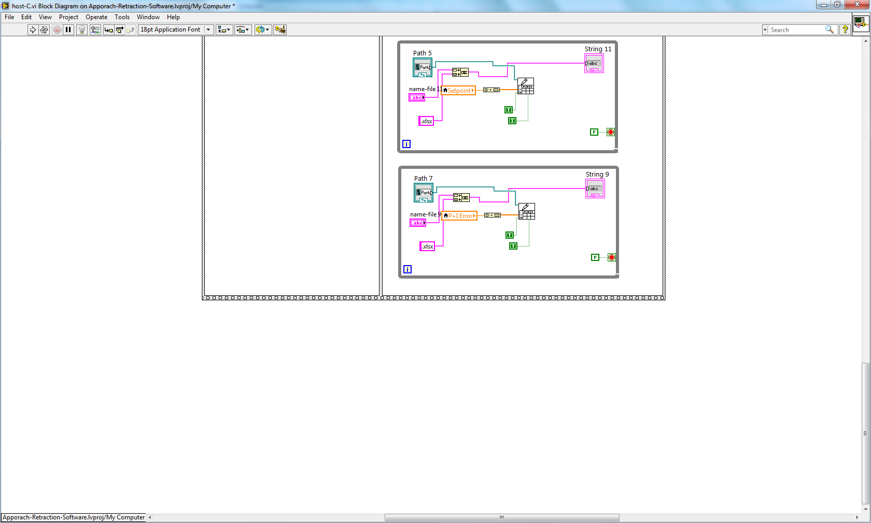

These while loops each contain a data collecting device for a unique set of data. Each while loop builds an excel spreadsheet and records the values over time. The next time I come will be collecting data for frequency modulation.

Date: 2/15/2014

Entry: Frequency Modulation Data

The data I collected from frequency modulation testing is displayed below. I took a test in air and in vacuum to highlight the huge effects of environmental discrepancies. The first two data graphs are from the Lock-In Amplifier. The next three graphs are from my digital Lock-In Amplifier. The last two graphs are the PID and VCO. All of these graphs are taken in the tuning fork in the air. The second set of graphs were taken in vacuum.

The Lock-In graphs and the graphs of the SR-850 are essentially identical in the detected phase, amplitude, and frequency. The PID error output and the VCO frequency output have outputted similar graphs and it describes how closely the VCO is able to mirror the PID error output. The graphs of the tuning fork in vacuum show how the maximum amplitude in vacuum is around 350 nanoamps whereas in air, the maximum amplitude is 60 nanoamps.